**Cardiff Metropolitan University**

**B.Sc. (Hons) in Business Information Systems**

**Assignment Cover Sheet**

|  |  |  |  |  |  |  |  |  |  |
| --- | --- | --- | --- | --- | --- | --- | --- | --- | --- |
| **Student Details ( Student should fill the content)** | | | | | | | | | |
| Name | | | Mohamed Hirsi Saadh | | | | | | |
| Student ID | | | ST20208732 | | | | | | |
| **Scheduled unit details** | | | | | | | | | |
| Unit code | | | CIS6008 | | | | | | |
| Unit title | | | Analytics and Business Intelligence | | | | | | |
| Unit enrolment details | | | Year | | 3 | | | | |
| Study period | | 2023 | | | | |
| Lecturer | | | Assignment prepared by Induranga De Silva | | | | | | |
| Mode of delivery | | | Full Time | | | | | | |
| **Assignment Details** | | | | | | | | | |
| Nature of the Assessment | | | Coursework (a report) | | | | | | |
| Topic of the Case Study | | | Application of statistical and geospatial business analytics tools, techniques and methodologies to generate business intelligence essential for informed decision making in Power and Renewable Energy sector credible, efficient and effective informed decision making in Sri Lanka. | | | | | | |
| Learning Outcomes covered | | | LO2, LO3, LO4 | | | | | | |
| Word count | | | 3200(report) | | | | | | |
| Due date / Time | | | 06st August 2023 | | | | | | |
| Extension granted? | | | Yes | No | Extension Date | | |  | |
| Is this a resubmission? | | | Yes | No | Resubmission Date | | |  | |
| **Declaration** | | | | | | | | | |
| I certify that the attached material is my original work. No other person’s work or ideas have been used without acknowledgement. Except where I have clearly stated that I have used some of this material elsewhere, I have not presented it for examination / assessment in any other course or unit at this or any other institution | | | | | | | | | |
| Name/Signature | | | Mohamed Hirsi Saadh | | | Date | | 06/09/2023 | |
| **Submission** | | | | | | | | | |
| Return to: | | |  | | | | | | |
| **Result** | | | | | | | | | |
| Marks by 1st Assessor |  | Name & Signature of the 1st Assessor | | | | |  | | **Agreed Mark** |
| Marks by2nd Assessor |  | Name & Signature of the 2nd Assessor | | | | |  | |
| Comments on the Agreed mark |  | | | | | | | | |

|  |  |  |  |  |  |  |  |  |  |
| --- | --- | --- | --- | --- | --- | --- | --- | --- | --- |
| **STUDENT NAME:**  MOHAMED HIRSI SAADH  **CMU B.Sc. (HONS) BIS - ASSIGNMENT FEEDBACK SHEET –ICBT CAMPUS** | | | | | | | | | **STUDENT NUMBER:**  ST20208732 |
| **Module Number & Title**: Analytics and Business Intelligence | | | | | | | | | **Semester: II** |
| **Assignment Type & Title:** Coursework  Application of statistical and geospatial business analytics tools, techniques, and methodologies to generate business intelligence essential for informed decision making in Power and Renewable Energy sector credible, efficient and effective informed decision making in Sri Lanka. | | | | | | | | | |
| **For student use: Critical feedback on the individual progression towards achieving the assignment outcomes** | | | | | | | | | |
|  | | | | | | | | | |
| **For the Assessors’ feedback**  **Indicate the Task number strength and Weaknesses and the marks for each task** | | | | | | | | | |
| **Task No/Question No** | **Strengths (1st Assessor)** | | | | | **Strengths (2nd Assessor)** | | | |
| **Task No / Question No** | **Weaknesses (1st Assessor)** | | | | | **Weaknesses (2nd Assessor)** | | | |
| **Areas for future improvement** | | | | | | | | | |
| **Comments by 1st Assessor** | | | | | | | **Comments by 2nd Assessor** | | |
| **Marks** | | | | | | | | | |
| **Task /Question No** | | **Marks by 1st Assessor** | **Marks by 2nd Assessor** | | **Marks by IV (if any)** | | **IV comments (If Any)** | | |
|  | |  |  | |  | |  | | |
|  | |  |  | |  | |
|  | |  |  | |  | |
| **Total Marks** | |  |  | |  | |
| **Name and the Signature of the 1st Assessor** | | | |  | | | **Date:** |  | |
| **Name & Signature of the 2ndAssessor :** | | | |  | | | **Date :** |  | |
| **Name & Signature of the IV: (If any)** | | | |  | | | **Date :** |  | |

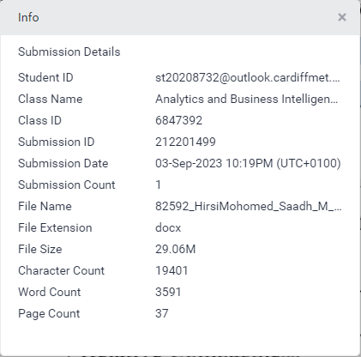

# ACKNOWLEDGEMENT

Foremost, I, Mohamad Hirsi Saadh, a student in batch 10 of the BSc in Computing and Software Engineering, would like to convey my heartfelt gratitude and appreciation to Mr. Asanka Dinesh, lecturer in Computational Intelligence for his unwavering support, patience, encouragement, and passion. Throughout the execution of my work, he provided me with a lot of information about this module. Aside from my lecturer, I'd want to express my gratitude to my other classmates and for their assistance and support in completing my work.

In addition, I'd want to thank the entire ICBT management and team for being so friendly and helpful, as well as for giving me this chance to showcase my skills via an assignment.

Finally, I'd want to convey my heartfelt appreciation to my family for their unwavering support and optimistic attitude throughout this report.

# EXECUTIVE SUMMARY

This report presents a comprehensive analysis employing Geo Spatial and Statistical Analysis methods across various sectors. Divided into eight chapters, it delves into critical aspects of data analytics, each contributing valuable insights and solutions.

Chapter one investigates energy efficiency in building cooling in the USA, focusing on factors to reduce electricity consumption. Chapter two develops a statistical model for predicting cooling load using regression analysis based on Chapter 1's data.

Chapter three maps land suitable for wind power plants across Sri Lanka using data from the Renewable Energy Resource Development Plan and Chapter four highlights potential land for solar power development in Sri Lanka and assesses its role in addressing energy sector challenges.

The next chapter digitizes and preserves an informative area map in Hambantota, incorporating solar power plants, forests, trees, and suburbs using shapefiles. While chapter six performs Geo Spatial analysis to create a thematic map, visualizing data from the Sri Lanka Sustainable Energy Authority within the PostgreSQL database "SLPetrolium-2023."

Chapter seven identifies feasible locations for renewable energy generation in Sri Lanka, pinpointing them on a map using Google Earth Pro and QGIS. And chapter eight determines suitable land for the "Regional Research Center for Renewable Energy" in Kandy, Sri Lanka, based on specific criteria.

The report concludes with a synthesis of findings from each chapter. Appendices contain supporting evidence. This extensive analysis underscores the critical role of data analytics in diverse sectors, offering solutions and insights for energy efficiency and renewable energy development.

# CONTENTS

ACKNOWLEDGEMENT V

EXECUTIVE SUMMARY VI

CONTENTS VII

LIST OF FIGURES X

LIST OF TABLES XII

ABBREVIATIONS XIII

INTRODUCTION 1

CHAPTER One 3

R STUDIO ANALYTICS 3

1.1. Main Hypothesis Statements 4

1.2. Data Pre-Processing 4

1.3. Data Visualization 4

1.3.1. Dataset Size 4

1.3.2. Data Visualization 5

1.3.3. Summary statistics of the data 7

1.4. Cooling Load and other factors 7

1.4.1. Relative Compactness and the Cooling Load 7

1.4.2. Surface Area and the Cooling Load 7

1.4.3. Wall Area and the Cooling Load 8

1.4.4. Roof Area and the Cooling Load 8

1.4.5. Overall Height and the Cooling Load 8

1.4.6. Glazing Area and the Cooling Load 9

1.5. Correlation Tests 9

1.5.1. Correlation Heatmap 9

1.5.2. Hypothesis Based Correlation Testing 10

1.5.2.1. Relative Compactness 10

1.5.2.2. Surface Area 11

1.5.2.3. Wall Area 11

1.5.2.4. Roof Area 12

1.5.2.5. Overall Height 12

1.6. Chapter Review 13

CHAPTER Two 14

THE STATISTICAL MODEL 14

2.1. Regression Analysis 14

2.1.1. Summary statistics for the linear regression model 14

2.1.2. Linear regression model 15

2.1.3. Shapiro-Wilk Test 17

2.2. Statistical Model 18

CHAPTER Three 19

SRI LANKA WIND POWER DEVELOPMENT PLAN 19

3.1. Land Available for wind power development data 19

CHAPTER Four 23

POTENTIAL LAND FOR SOLAR POWER DEVELOPMENT 23

4.1. Land available for solar power development data 23

4.2. Solar Power Potential and Land Usage in Sri Lanka 24

CHAPTER Five 26

DIGITIZED INFORMATIVE AREA MAP 26

5.1. Pre digitalized map 26

5.2. Digitized area map 26

5.3. Overcoming energy sector problems using solar power 27

CHAPTER Six 28

SRI LANKA PETROLEUM DISTRIBUTION 28

6.1. Fuel statistics of Sri Lanka by district 29

6.2. Geo Spatial Database 30

CHAPTER Seven 31

LOCATIONS FOR RENEWABL ENERGY GENERATION 31

7.1. Factors considered when selecting a location. 31

7.2. Feasible Locations 31

7.2.1. Solar Power 31

7.2.2. Wind Power 32

7.2.3. Biomass 33

7.3. Mapping the locations 33

CHAPTER Eight 35

RENEWABLE ENERGY RESEARCH CENTER FOR KANDY 35

8.1. Criteria for the suitable Area 35

8.2. Suitable area for the newly developing research center 35

CONCLUSION 37

GANTT CHART i

REFERENCES ii

APPENDIX A iii

APPENDIX B iv

APPENDIX C v

APPENDIX D viii

APPENDIX E x

APPENDIX F xiii

APPENDIX G xviii

APPENDIX H xxii

# 

# LIST OF FIGURES

Figure 1.1: Head of energy_efficient_data.csv 3

Figure 1.2: Importing data to RStudio. 4

Figure 1.3: Size of the dataset to be analyzed. 4

Figure 1.4: Energy Efficiency Data in Histogram - 1 5

Figure 1.5: Energy Efficiency Data in Histogram - 2 6

Figure 1.6: Summary statistics of energy efficiency dataset 7

Figure 1.7: Scatter Plot for relative compactness with the cooling load 7

Figure 1.8: Scatter Plot for Surface Area with the cooling load 7

Figure 1.9: Scatter Plot for Wall Area with the cooling load 8

Figure 1.10: Scatter Plot for Roof Area with the cooling load 8

Figure 1.11: Scatter Plot for Overall Height with the cooling load 8

Figure 1.12: Scatter Plot for Glazing Area with the cooling load 9

Figure 1.13: Correlational Heatmap 9

Figure 1.14: Correlation Matrix 10

Figure 1.15: Pearson Cors test between Cooling Load and Relative Compactness 10

Figure 1.16: Pearson Cors test between Cooling Load and Surface Area 11

Figure 1.17: Pearson Cors test between Cooling Load and Wall Area 11

Figure 1.18: Pearson Cors test between Cooling Load and Roof Area 12

Figure 1.19: Pearson Cors test between Cooling Load and Overall Height 12

Figure 2.1: Summary statistics of linear regression function 14

Figure 2.2: Updated summary statistics of linear regression function 15

Figure 2.3: Printed linear regression model. 15

Figure 2.4: Created linear regression function. 15

Figure 2.5: Shapiro normality testing 17

Figure 2.6: The model 17

Figure 3.1: Land available for wind power plant development (Sustainable Energy Authority, 2023) 19

Figure 3.2: Total Land Available in each district for Wind Power development 20

Figure 3.3: Types of land available in each district 22

Figure 4.1:Land available for solar power plant development (Sustainable Energy Authority, 2023) 23

Figure 4.2: Potential land for Solar Power development 24

Figure 5.1: Pre digitalized map 26

Figure 5.2: Digitized Area map 26

Figure 6.1: SL Petroleum Data 28

Figure 6.2: Fuel statistics of Sri Lanka by District 29

Figure 6.3: Geo Spatial database created for SL Petroleum distribution. 30

Figure 7.1: Feasible locations for renewable energy development 34

Figure 8.1: Suitable area for the research center 35

Figure 8.2: Suitable area 36

# LIST OF TABLES

Table 1.1: Categorical and continuous values of energy efficiency dataset 3

Table 1.2: Main Hypothesis 4

Table 1.3: Hypothesis Statement One 10

Table 1.4: Hypothesis Statement Two 11

Table 1.5: Hypothesis Statement Three 11

Table 1.6: Hypothesis Statement Four 12

Table 1.7: Hypothesis Statement Five 12

Table 2.1: Interpretation of Figure 2.3 16

Table 2.2: Model Explanation 18

Table 7.1: Feasible locations for Solar Power 31

Table 7.2: Feasible locations for wind power development 32

Table 7.3: Feasible locations for biomass power development 33

Table 8.1: criteria for the suitable area 35

Table 8.2: Statistics of the suitable location 36

# ABBREVIATIONS

|  |  |
| --- | --- |
| QGIS | Quantum Geographic Information System |
| SL | Sri Lanka |
| USA | United States of America |

# INTRODUCTION

In today’s world data analytics is crucial in almost every sector in the world. To maximize the use of analytics there are various methods. Some are Geo Spatial analysis and Statistical Analysis. Geo Spatial analysis mostly consists of maps and geographical data and Statistical Analysis consists of graphs, charts, and predictions along with other insights. This report consists of some both these analyses conducted in various sectors.

The first chapter consists of an analysis related to the energy efficiency in building cooling and its associations with various other factors to reduce residential and commercial electricity consumption. The data are obtained from a case study in the USA.

The second chapter is all about creating a statistical model to predict the cooling load by using the data obtained from chapter one. Regression analysis must be done to complete the chapter.

The third chapter consists of maps that are developed to showcase the lands that are available to develop wind power plants in each district. The data for the maps are obtained from the Renewable Energy Resource Development Plan of Sri Lanka.

The fourth chapter consists of a map that has been created to showcase the potential land for solar power development by using the data obtained from the Sri Lanka sustainable energy authority. Along with an analysis of how solar power energy would contribute for overcoming energy sector problems.

The fifth consists of the digitized informative area map of a place in Hambantota. The solar power plants, forests, trees, and other suburbs are digitized and saved as shape files in this chapter.

The sixth consists of geo spatial analysis done to visualize a thematic map classified by using the data provided by the Sri Lanka Sustainable Energy Authority. A database using PostgreSQL named “SLPetrolium-2023” is created and the data are visualized in the map.

The seventh chapter is about feasible locations for Renewable Energy Generation in Sri Lanka identified by the Sri Lanka Energy Authority. A map is drawn to pinpoint the exact feasible locations using Google Earth Pro and QGIS.

The final chapter consists of a map that is developed to find suitable land for the newly developing ‘*Regional Research Center for Renewable Energy*’ in Kandy. The suitable area in the map is developed using the criteria provided in the task and the total number of buildings within the suitable area at present, land area occupied by the buildings, and total suitable land area is found out.

Finally, the document is concluded with a conclusion of the report. All evidence related to the tasks are attached in the respective appendix.

# 

## R STUDIO ANALYTICS

This chapter consists of an analysis related to the energy efficiency in building cooling and its associations with various other factors to reduce residential and commercial electricity consumption. The goal is to analyze ‘*energy_efficiency_data.csv*’ and provide critical discussions on how structural factors related to the shape of a building are affecting building cooling and have an impact in the energy generation.

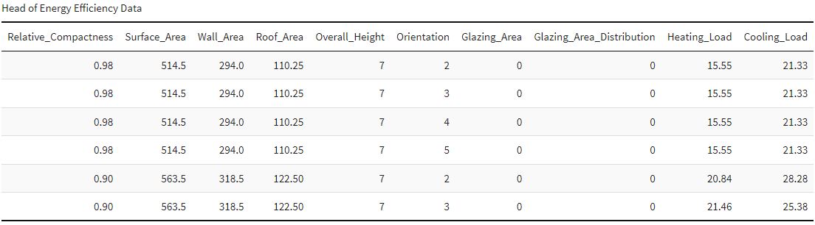

Figure .: Head of energy_efficient_data.csv

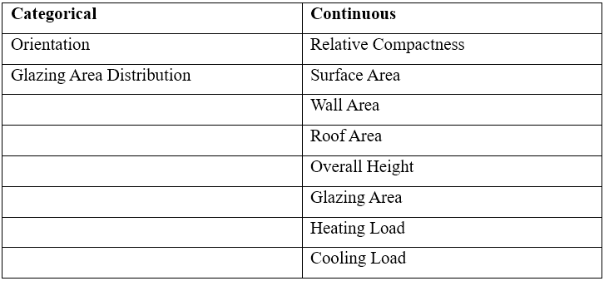The above figure 1.1 depicts the head of the dataset that is to be analyzed. This data is extracted from a case study in the USA. The table consists of multiple variables such as *‘Relative_Compactness’, ‘Surface_Area’, ‘Wall_Area’, ‘Roof_Area’, ‘Overall_Height’, ‘Orientation’, ‘Glazing_Area’, ‘Glazing_Area_Distribution’, ‘Heating_Load’,* and *‘Cooling_Load.’* All these variables are crucial in cooling a building and can affect the efficiency of energy usage. By analyzing this dataset, the decision makers can get a good knowledge regarding how the structural factors related to the shape of a building are affecting energy generation.

Table .: Categorical and continuous values of energy efficiency dataset

**Building Cooling and Other Structural Factors related to the shape of the building.**

### Main Hypothesis Statements

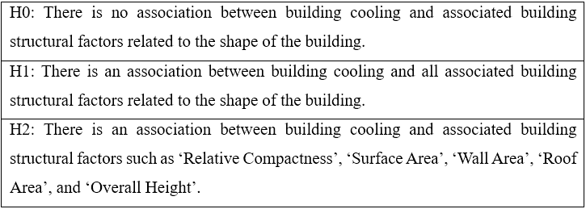

Table .: Main Hypothesis

**Note:** The heating load from the dataset won’t be used to find relationships because it is not a structural factor of a building, and it does not affect the shape of the building.

* Significance level (x) = 0.05 (5%)
* Confidence level = 0.95 (95%)

### Data Pre-Processing

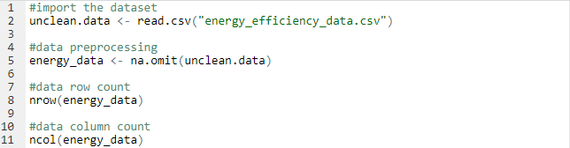

Figure .: Importing data to RStudio.

Figure 1.2 depicts the code that is used to import and clean the dataset into RStudio.

### Data Visualization

#### Dataset Size

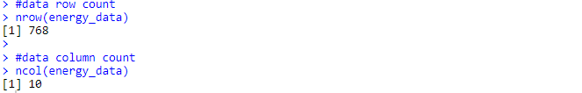

Figure .: Size of the dataset to be analyzed.

The above figure 1.3 shows the number are of columns and rows that are available in the dataset which are **10** and **768** respectively.

#### Data Visualization

As you can see in figures 1.4 and 1.5 the data are shown in histograms. When it comes to the Relative Compactness, Wall Area, Overall Height, Glazing Area, Surface Area, Roof Area, Orientation, and Glazing Area Distribution columns contain mostly repetitive values because there are few bars in their histograms. However, we can see that the cooling load data and heating load data have multiple values under them. The data can be further investigated by using the summary statistics function in R.

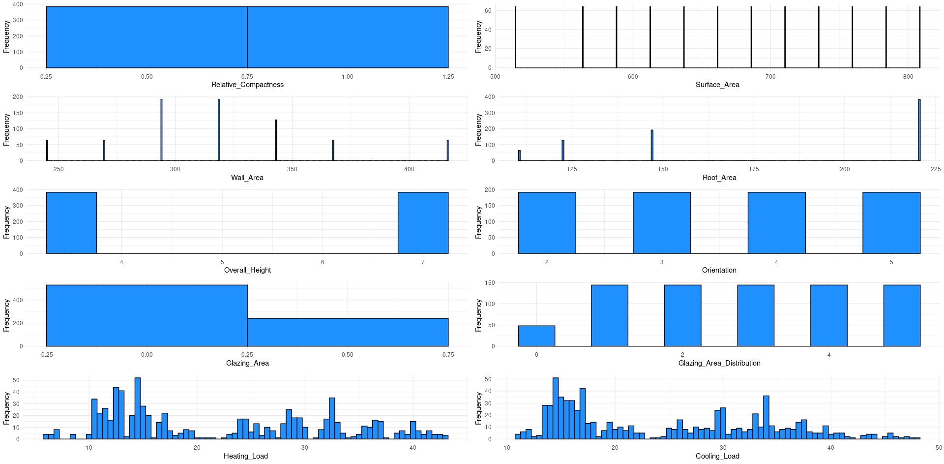

Figure .: Energy Efficiency Data in Histogram - 1



Figure .: Energy Efficiency Data in Histogram - 2

#### Summary statistics of the data



Figure .: Summary statistics of energy efficiency dataset

As depicted in figure 1.6, the summary function of R is used to get an idea of the energy efficiency dataset that will be analyzed for associations between the cooling load and structural factors.

### Cooling Load and other factors

The cooling load factor will be compared with the other factors that could affect cooling by using scatter plots and their impact on the relationship can be seen.

#### Relative Compactness and the Cooling Load

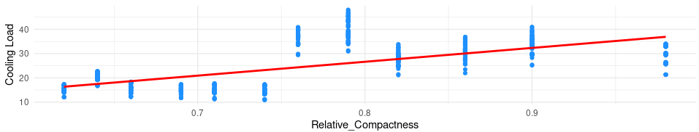

Figure .: Scatter Plot for relative compactness with the cooling load

The above figure 7.1 depicts that there is a positively increasing relationship between relative compactness and the cooling load.

#### Surface Area and the Cooling Load

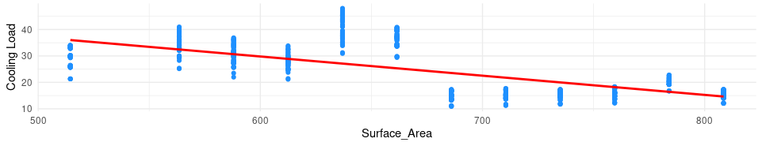

Figure .: Scatter Plot for Surface Area with the cooling load

According to figure 1.8, it is known that when the surface area is increasing the cooling load decreases. There is a negatively decreasing relationship between surface area and cooling load.

#### Wall Area and the Cooling Load

Figure 1.9 depicts that there is a positively increasing relationship between the cooling load and wall area.

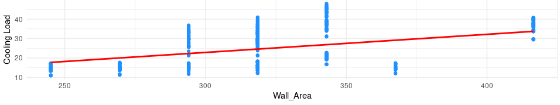

Figure .: Scatter Plot for Wall Area with the cooling load

#### Roof Area and the Cooling Load

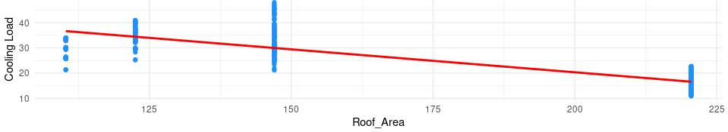

Figure .: Scatter Plot for Roof Area with the cooling load

When the roof area increases the cooling load decreases, resulting in a negatively decreasing relationship according to figure 1.10.

#### Overall Height and the Cooling Load

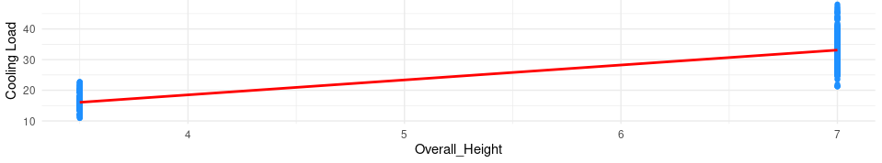

Figure .: Scatter Plot for Overall Height with the cooling load

There is a positive relationship between the overall height and the cooling load of a building according to figure 1.11.

#### Glazing Area and the Cooling Load

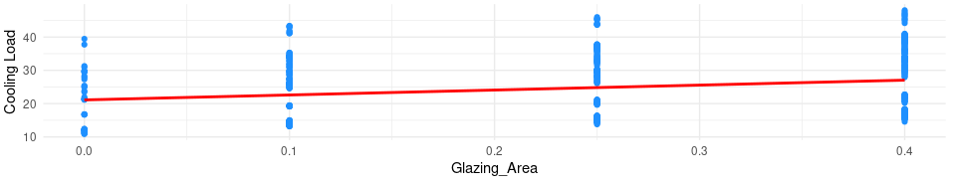

Figure .: Scatter Plot for Glazing Area with the cooling load

According to figure 1.12 there is no significant positive relationship between the Glazing area and the cooling load, instead it shows a slightly positive increase. To know more about the relationships and associations correlation tests are conducted.

### Correlation Tests

The correlation tests will be conducted to find the associations between the cooling load and structural factors affecting cooling load in a building.

#### Correlation Heatmap

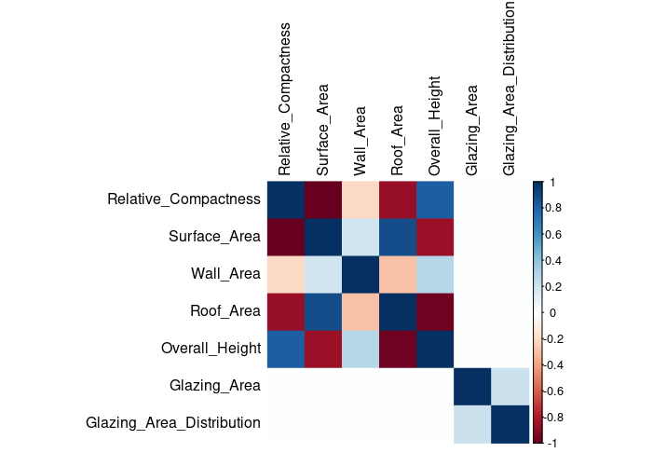

Figure .: Correlational Heatmap

Figure 1.13 depicts the correlation matrix that is developed to uncover the associations between cooling load and other structural factors. According to the graph drawn Relative Compactness, Surface Area, Wall Area, Roof Area, and Overall Height have correlations with the cooling load. Refer to figure 1.14 below for detailed statistics on the correlational heatmap. The Glazing area and glazing area are not considered because there is no correlation to the cooling load.

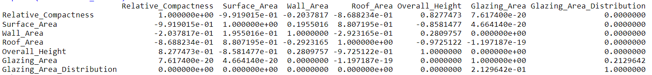

Figure .: Correlation Matrix

#### Hypothesis Based Correlation Testing

This phase is to find out correlation between the structural factors and the cooling load.

##### Relative Compactness

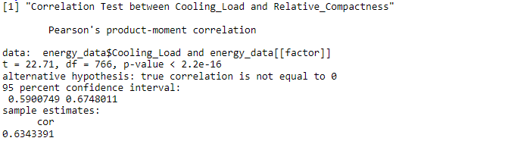

Figure .: Pearson Cors test between Cooling Load and Relative Compactness

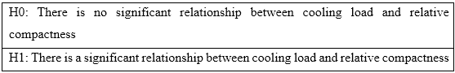

Table .: Hypothesis Statement One

The Pearson correlation test between cooling load and relative compactness indicates that there is a statistically significant and moderately strong positive linear relationship based on the correlation coefficient ‘0.6343391’ and a very small p-value rejecting the null hypothesis.

**Decision:** p-value = 2.2e-16/cor=0.6343391 > Reject H0

##### Surface Area

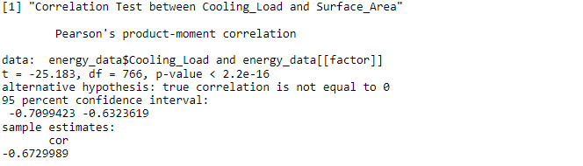

Figure .: Pearson Cors test between Cooling Load and Surface Area

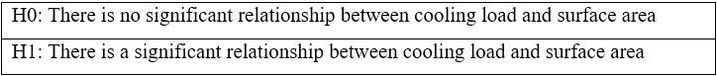

Table .: Hypothesis Statement Two

Figure 1.16 depicts that there is a strong and significant negative linear relationship between the cooling load and surface area due to the correlation coefficient of ‘-0.6729989’ and a very small p-value of 2.2e-16, thus rejecting the null hypothesis.

**Decision:** p-value = 2.2e-16/cor=-0.6729989> Reject H0

##### Wall Area

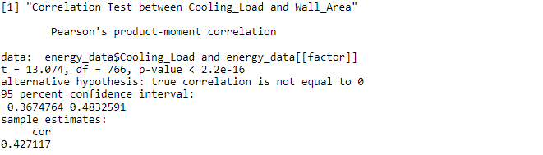

Figure .: Pearson Cors test between Cooling Load and Wall Area

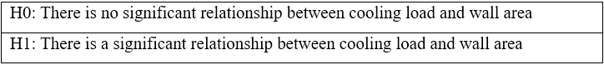

Table .: Hypothesis Statement Three

The output shows that there is a statistically significant and moderate positive linear relationship between the cooling load and wall area based on the coefficient of ‘0.427117’ and the p-value of 2.2e-16. Rejecting the null hypothesis.

**Decision:** p-value = 2.2e-16/cor =0.427117> Reject H0

##### Roof Area

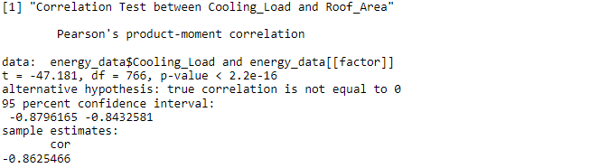

Figure .: Pearson Cors test between Cooling Load and Roof Area

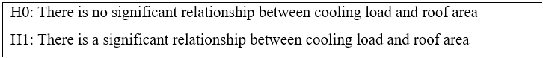

Table .: Hypothesis Statement Four

The above output depicts that there is a significant negative linear relationship between the cooling load and roof area based on the correlation coefficient of ‘-0.8625466’ and a minimal p-value of 2.2e-16.

**Decision:** p-value = 2.2e-16/cor=-0.8625466> Reject H0

##### Overall Height

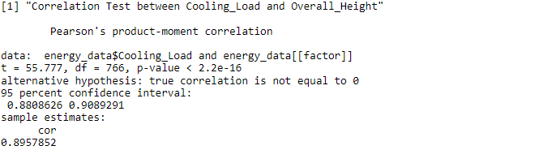

Figure .: Pearson Cors test between Cooling Load and Overall Height

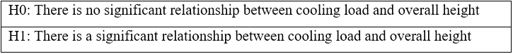

Table .: Hypothesis Statement Five

According to the output there is a significant and very strong positive linear relationship between cooling load and overall height based on the correlation coefficient ‘0.8957852’ and a very small p-value of 2.2e16.

**Decision:** p-value = 2.2e-16/cor=0.8957852> Reject H0

### Chapter Review

As per the analysis done previously it is visible that there is an association between the cooling load and Structural factors of a building such as the wall area, roof area, surface area, overall height, and the relative compactness. Therefore Main H0 is rejected and H1 can be rejected too because all structural factors do not have association between the cooling loads.

**Decision:** Reject Main Hypothesis’ H0 and H1 and H2 is True

Therefore when a building is constructed 'Relative Compactness', 'Surface Area', 'Wall Area', 'Roof-Area', and 'Overall Height' must be considered. Because these factors mostly affect the cooling load of a building which in turn affects the energy consumption of a building. This way we can reduce the high energy consumption that takes place in Sri Lanka.

**ALL CODES RELATED TO THIS CHAPTER ARE IN** **APPENDIX A**

# 

## THE STATISTICAL MODEL

The following chapter is about creating a precise statistical model by using the findings from the previous chapter.



### Regression Analysis

According to the hypothesis-based correlation tests done in the previous chapter it is believed that the factors associated with the cooling load are the relative compactness, surface area, wall area, roof area and overall height. Therefore by using these factors the regression analysis will be conducted.

#### Summary statistics for the linear regression model

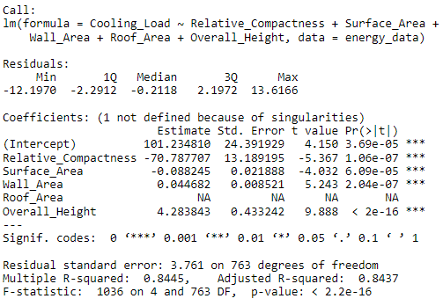

Figure .: Summary statistics of linear regression function

According to figure 2.1 when the structural factors were fit into a linear regression model with the cooling load it seems to be significant with low p-values for the F-Statistics, and the predictor variables except for the roof area variable. Therefore the model can be created without the roof area variable. Also the Adjusted R-squared of ‘0.8437’ suggests that the model has a substantial amount of variance in the cooling load.

**Decision:** Remove roof area from the model

The above figure 2.2 depicts the summary statistics for the linear regression model after removing the roof area from the equation. All other values do not appear to be varied.

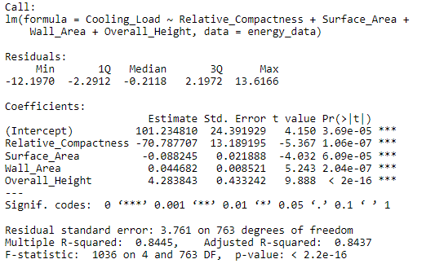

Figure .: Updated summary statistics of linear regression function

#### Linear regression model

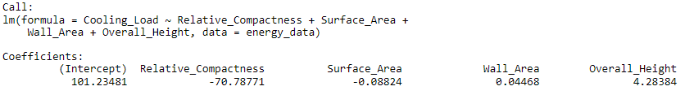

Figure .: Printed linear regression model.



Figure .: Created linear regression function.

The coefficients in figure 2.3 provide insight into how each predictor variable contributes to the prediction of the cooling load in the linear regression model. They provide the direction (positive/negative) in how each variable affects the dependent variable along with the magnitude of the impact. The below table provides more insight to figure 2.3.

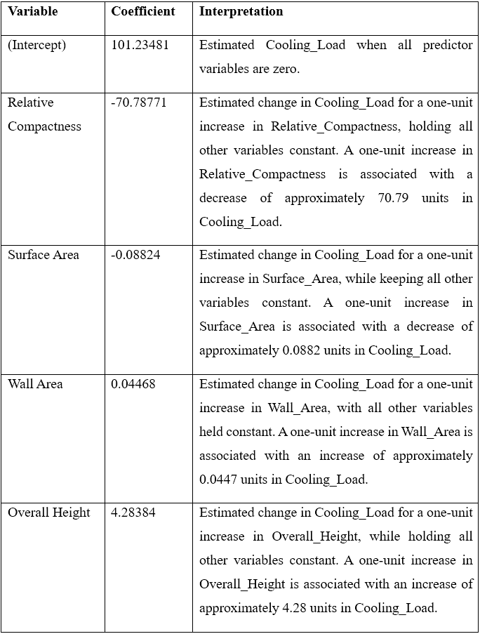

Table .: Interpretation of Figure 2.3

#### Shapiro-Wilk Test

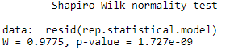

Figure .: Shapiro normality testing

According to the values obtained from the Shapiro test, it is known that the model is not normally distributed since the p-value is much smaller than the common significant level of 0.05. However the model can still be used in predictions and statistical models with some limitations.

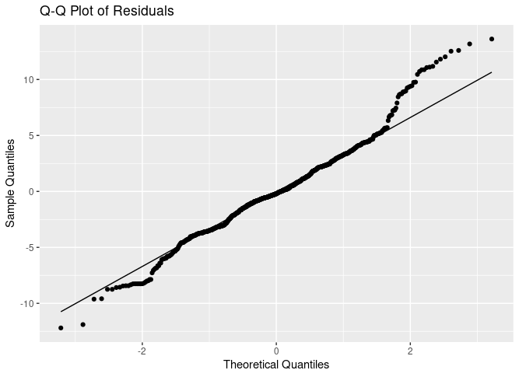

Figure .: The model

### Statistical Model

$$Y=X0+ X1*Relative Compactness+X2* Surface Area+X3* Wall Area+X4* Overall_Height+ E$$

Equation .: Statistical Model

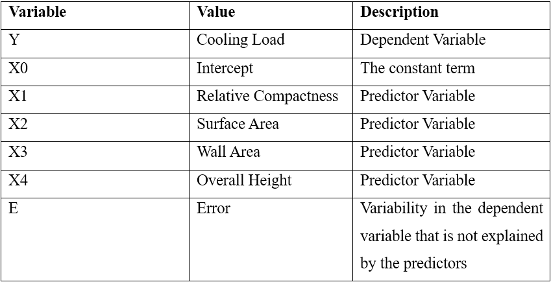

Table .: Model Explanation

The goal of the above statistical model in equation 2.1 is to understand how changes to the predictor variables are associated with the changes in the cooling load. During the regression analysis the values needed for the variables are extracted from the lm () function.

$$Y = 101.23 - 70.79 * Relative_Compactness - 0.0882 * Surface_Area + 0.0447 * Wall_Area + 4.28 * Overall_Height$$

Equation .: Actual Equation

The equation 2.2 depicts the equation with the values obtained from the linear regression analysis done previously. By using this equation it is possible to predict the Cooling Load of a building using the predictor variables.

This model can be used in Sri Lanka even before staring to construct the building and predict the cooling load. Where in turn we can use that to calculate the energy consumption that is required to cool down the building.

**ALL CODES RELATED TO THIS CHAPTER ARE IN** **APPENDIX B**

# 

## SRI LANKA WIND POWER DEVELOPMENT PLAN

The following chapter consists of maps that are developed to showcase the lands that are available to develop wind power plants in each district. The data for the maps are obtained from the Renewable Energy Resource Development Plan of Sri Lanka.

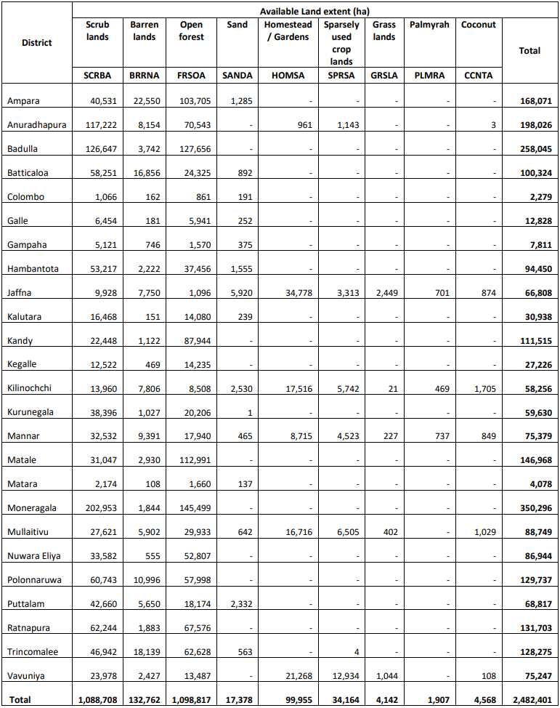

Figure .: Land available for wind power plant development (Sustainable Energy Authority, 2023)

### Land Available for wind power development data

The above figure 3.1 depicts the land that are available to develop wind power plants in Sri Lanka according to the Sustainable Energy Authority in Sri Lanka. The data is obtained and then saved as ‘*SLWindPowerLand_21_23.csv*’ to be used in the mapping.

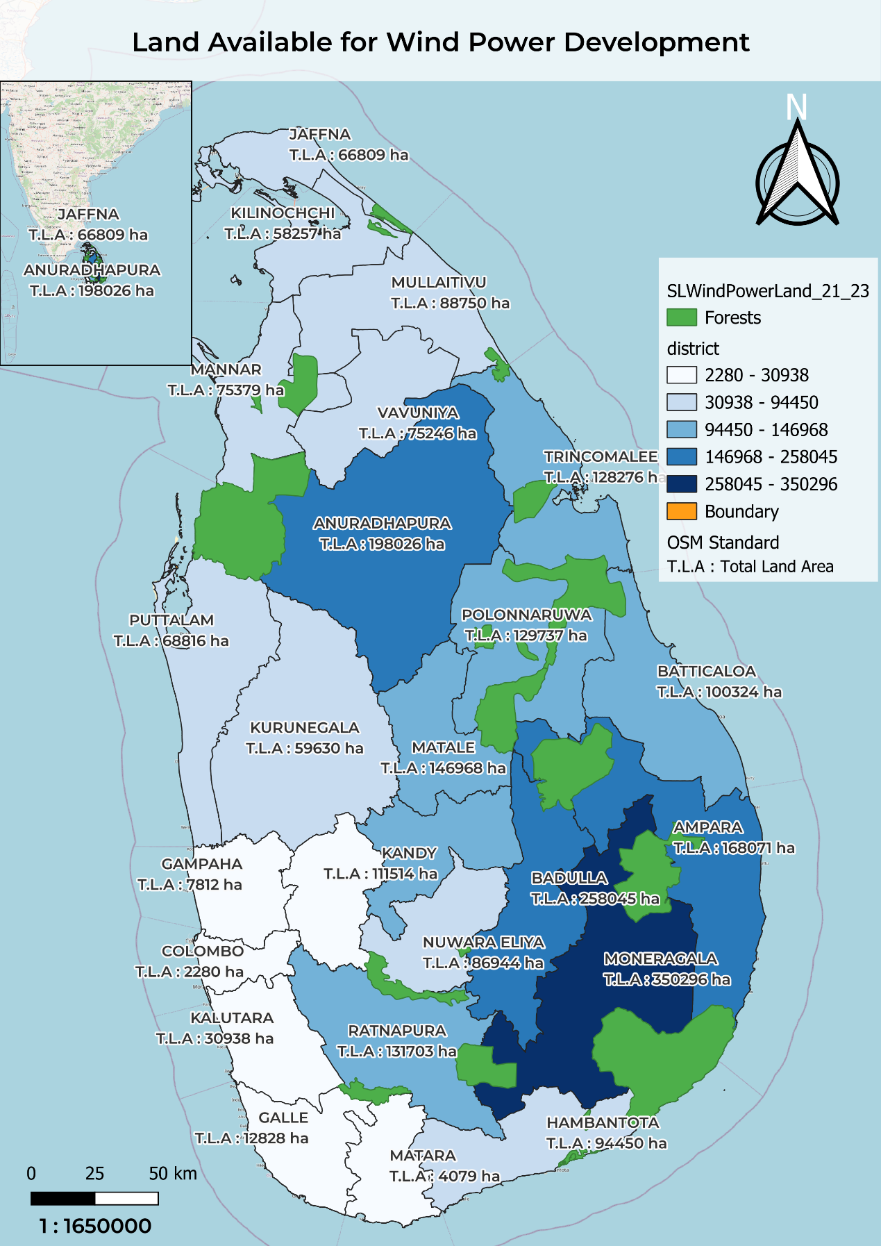

Figure .: Total Land Available in each district for Wind Power development

The thematic map in figure 3.2 illustrates the availability of land for wind power development across the districts of Sri Lanka. The data is obtained from the Renewable Energy Development Plan 2021-2026 provided by the Sri Lanka Sustainable Energy Authority.

The district is color-coded to represent the availability of land by using darker colors for indicating larger available land areas. Districts with significant land availability for wind power development include Monaragala, Badulla, Anuradhapura, and Ampara. Least number of land available is represented by the Western Province and Galle district. The most promising district for development is Anuradhapura when considering the population and transmission of electricity.

This map serves as a valuable tool for investors and decision makers in the renewable energy sector providing a clear visual representation forecasting potential land for wind power development.

**ALL STEPS RELATED TO THIS CHAPTER ARE IN** **APPENDIX C**

The map in figure 3.3 shows pie charts above the districts to show the type of land that is available to develop wind power plants.

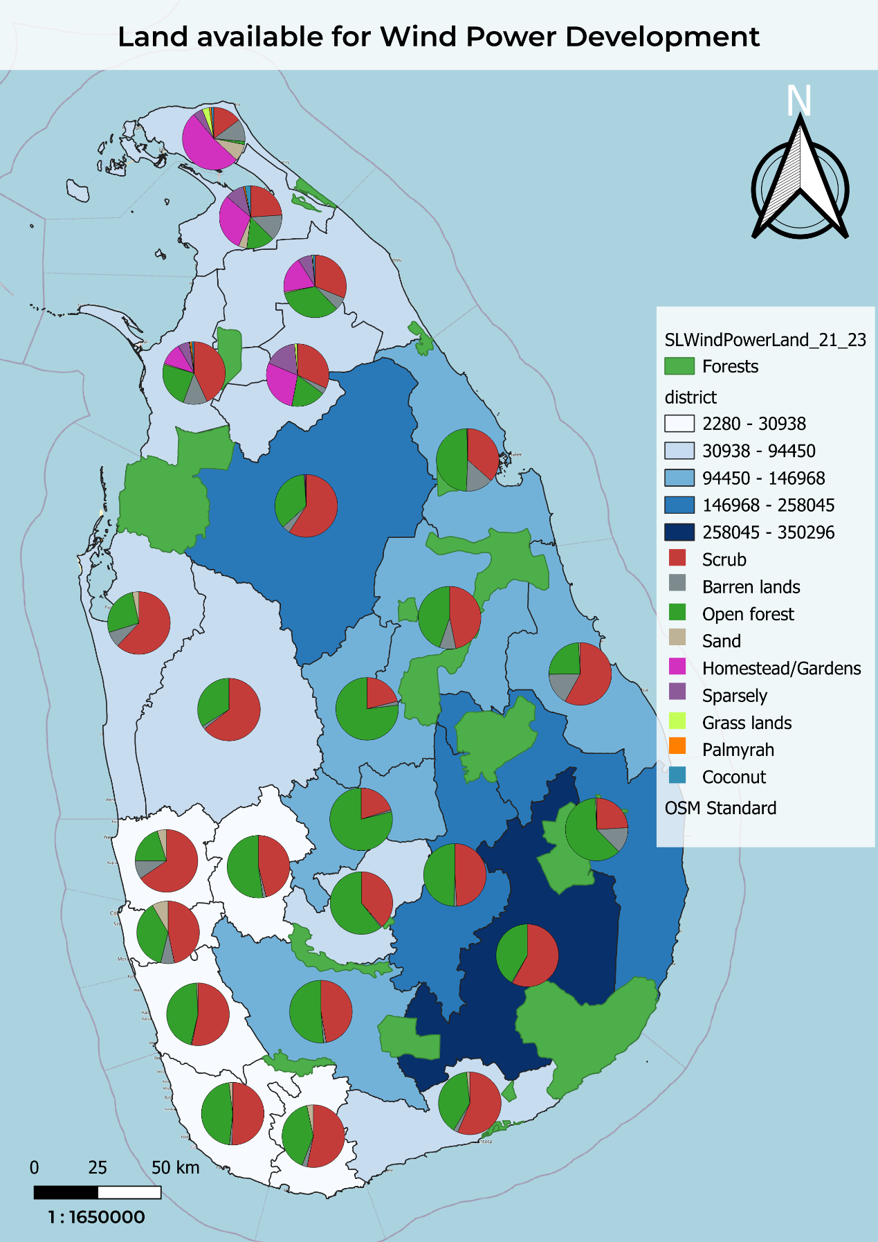

Figure .: Types of land available in each district

# 

## POTENTIAL LAND FOR SOLAR POWER DEVELOPMENT

The following chapter consists of the thematic map that has been created to showcase the potential land for solar power development by using the data obtained from the Sri Lanka sustainable energy authority. Along with an analysis of how solar power energy would contribute for overcoming energy sector problems.



### Land available for solar power development data

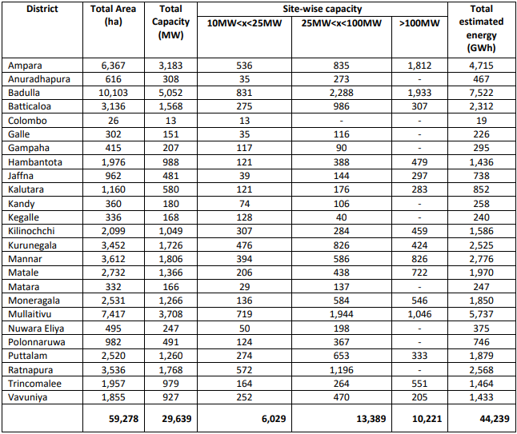The data in figure 4.1 shows the land available for solar power development along with the potential capacity and the estimated energy outputs from the plants in terms of each district (Sustainable Energy Authority, 2023).

Figure .:Land available for solar power plant development (Sustainable Energy Authority, 2023)

### Solar Power Potential and Land Usage in Sri Lanka

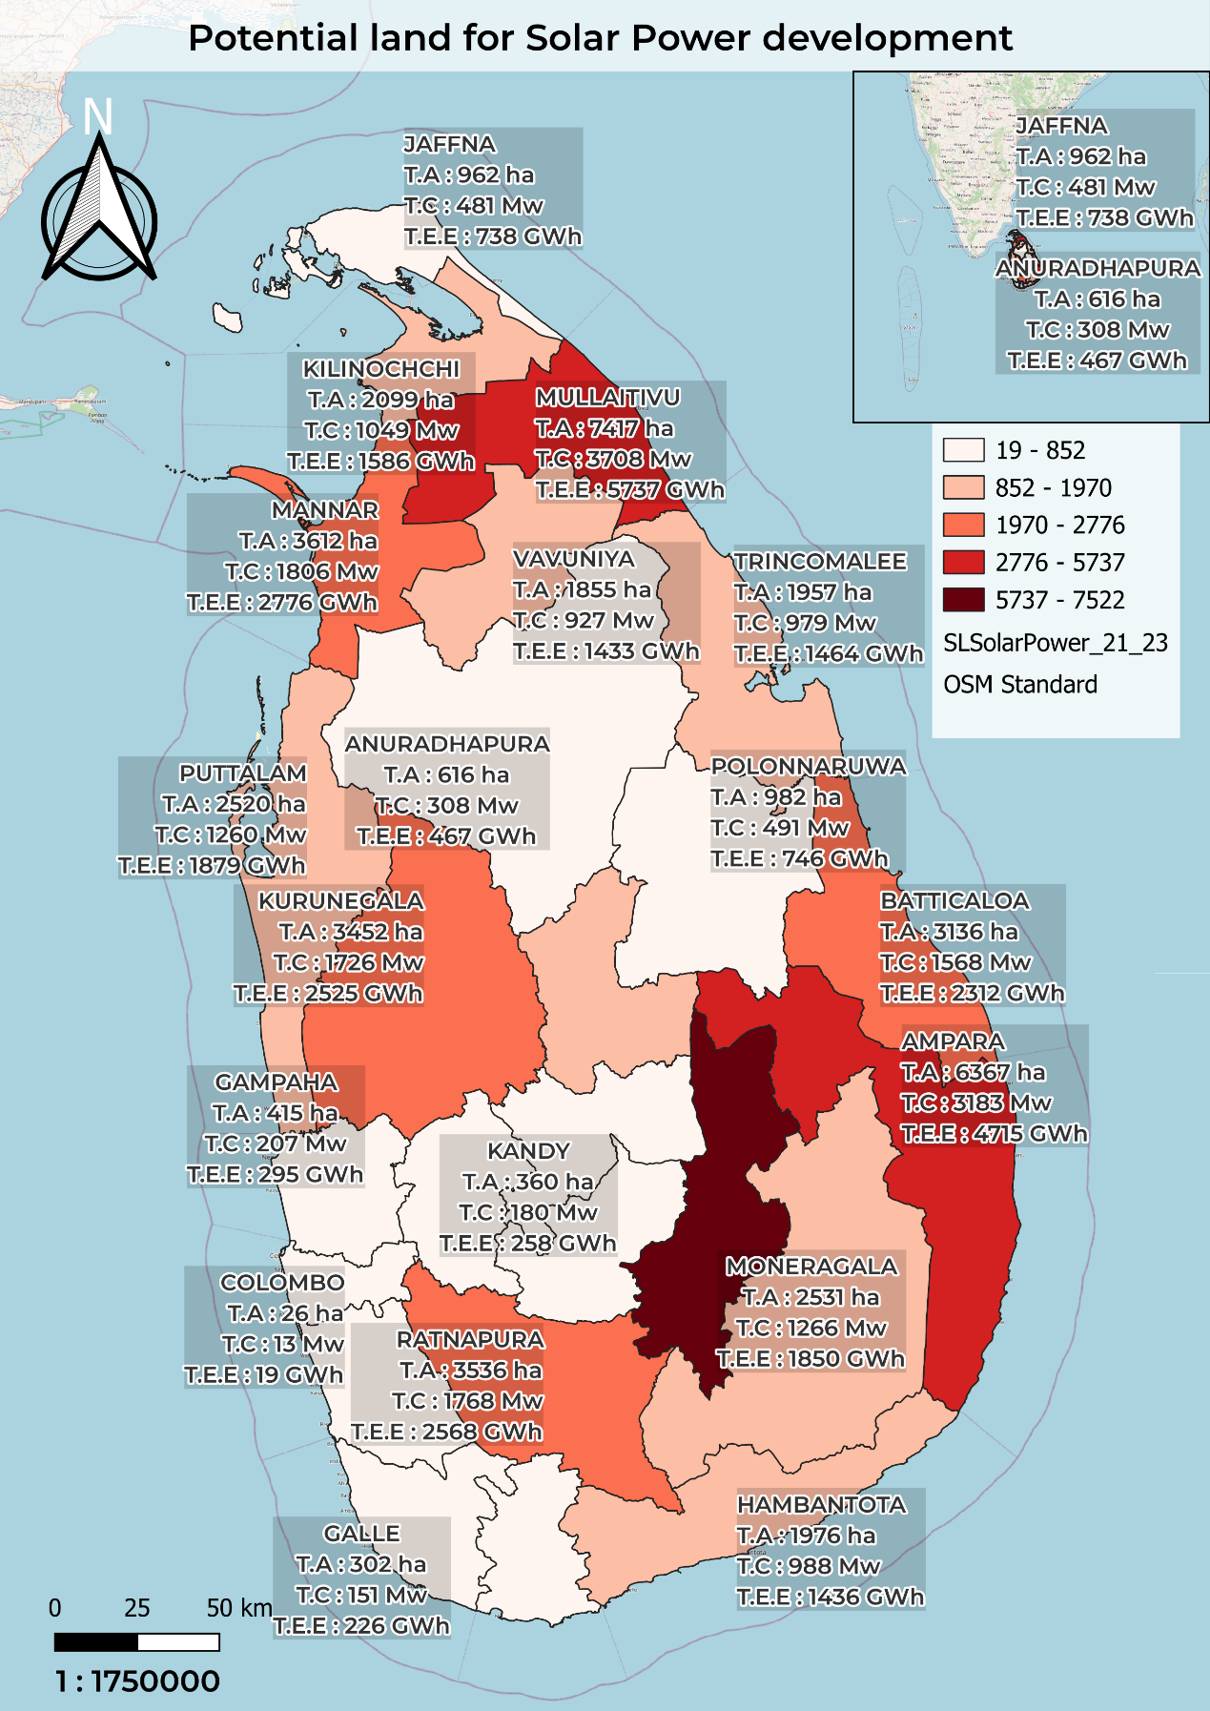

Figure .: Potential land for Solar Power development

The figure 4.2 consists of a map of Sri Lanka with a visual representation of the solar power potential and land usage across the different districts in the country. The above map utilizes a thematic approach to highlight the district with the highest land available for solar power plants development.

The darker the color the higher the land available for solar power development. According to the map Badulla, Ampara and Mullaitivu stand out with their deep shades of color, indicating higher solar power potential. Urban and densely populated districts such as Colombo, Kandy and Gampaha have relatively low potential in solar power development.

This map utilizes the importance of sustainable energy development by highlighting areas where solar energy can be properly harnessed without extensive wastages and preserving nature.

**ALL STEPS RELATED TO THIS CHAPTER ARE IN** **APPENDIX D**

# 

## DIGITIZED INFORMATIVE AREA MAP

The following chapter consists of the digitized informative area map of a place in Hambantota. The solar power plants, forests, trees, and other suburbs are digitized and saved as shape files in this chapter.



### Pre digitalized map

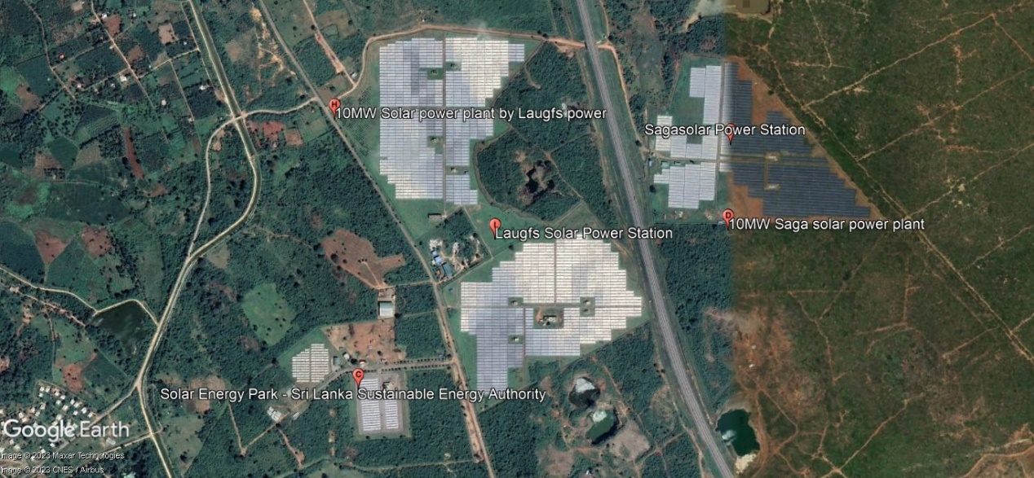

Figure .: Pre digitalized map

Figure 5.1 shows the map that should be digitized by creating vector layers/shape files.

### Digitized area map

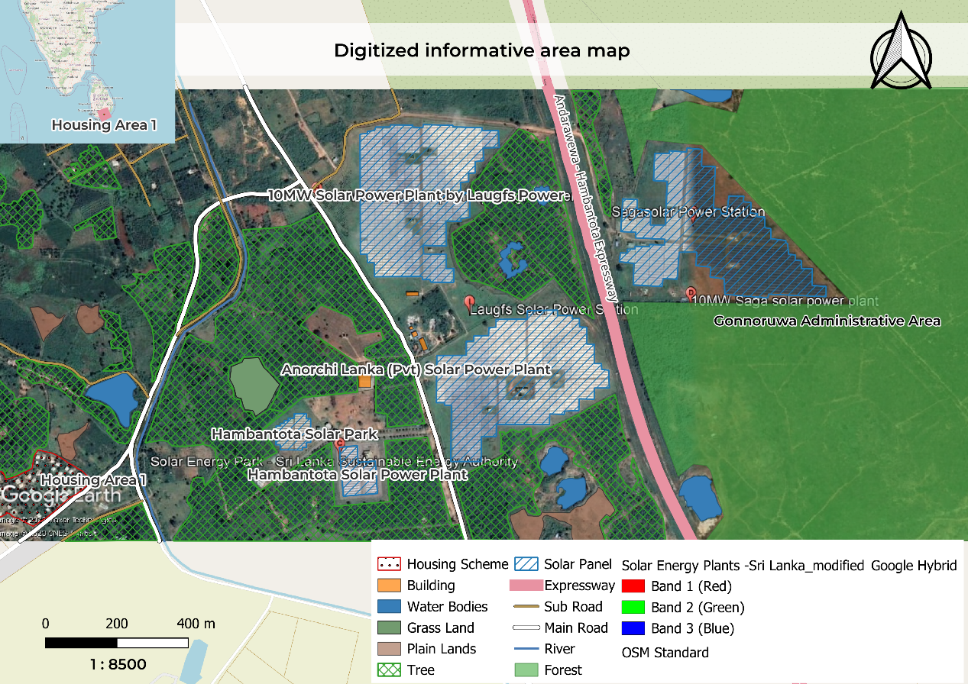

Figure .: Digitized Area map

The digitalized map in figure 5.2 is captured from an area in the Hambantota district near the Gonnoruwa forest area. This area is mostly concentrated with solar power plants and forest areas. There are various water bodies and plain areas with trees in the above digitized area map.

### Overcoming energy sector problems using solar power

Sri Lanka is a country with free sunshine the whole year. We can use it for the benefit of the country. For instance the small piece of land area depicted in figure 5.2 generates around 20Mw of electricity. Therefore by utilizing the land in Sri Lanka we can surpass our goal and generate surplus electricity. This could result in environmental benefits as well as reducing fuel imports in the country and can meet with the growing energy demand in the country.

**ALL STEPS RELATED TO THIS CHAPTER ARE IN** **APPENDIX E**

# 

## SRI LANKA PETROLEUM DISTRIBUTION

The following chapter consists of geo spatial analysis done to visualize a thematic map classified by using the data provided by the Sri Lanka Sustainable Energy Authority. A database using PostgreSQL named “SLPetrolium-2023” is created and the data are visualized in the map.

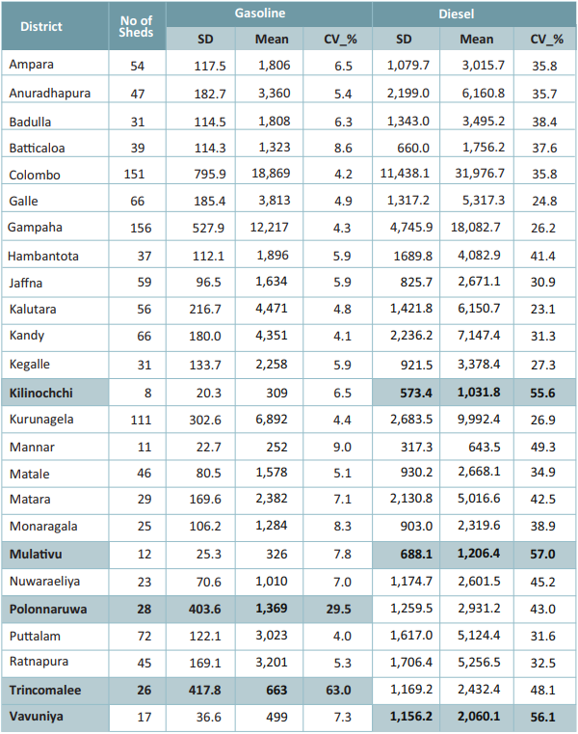

Figure .: SL Petroleum Data

The table in figure 1.6 shows the data provided by the authority. The table comprises of columns named District, No. of Sheds, mean and standard deviation of gasoline and diesel distribution in the country. The map is developed to forecast these details.

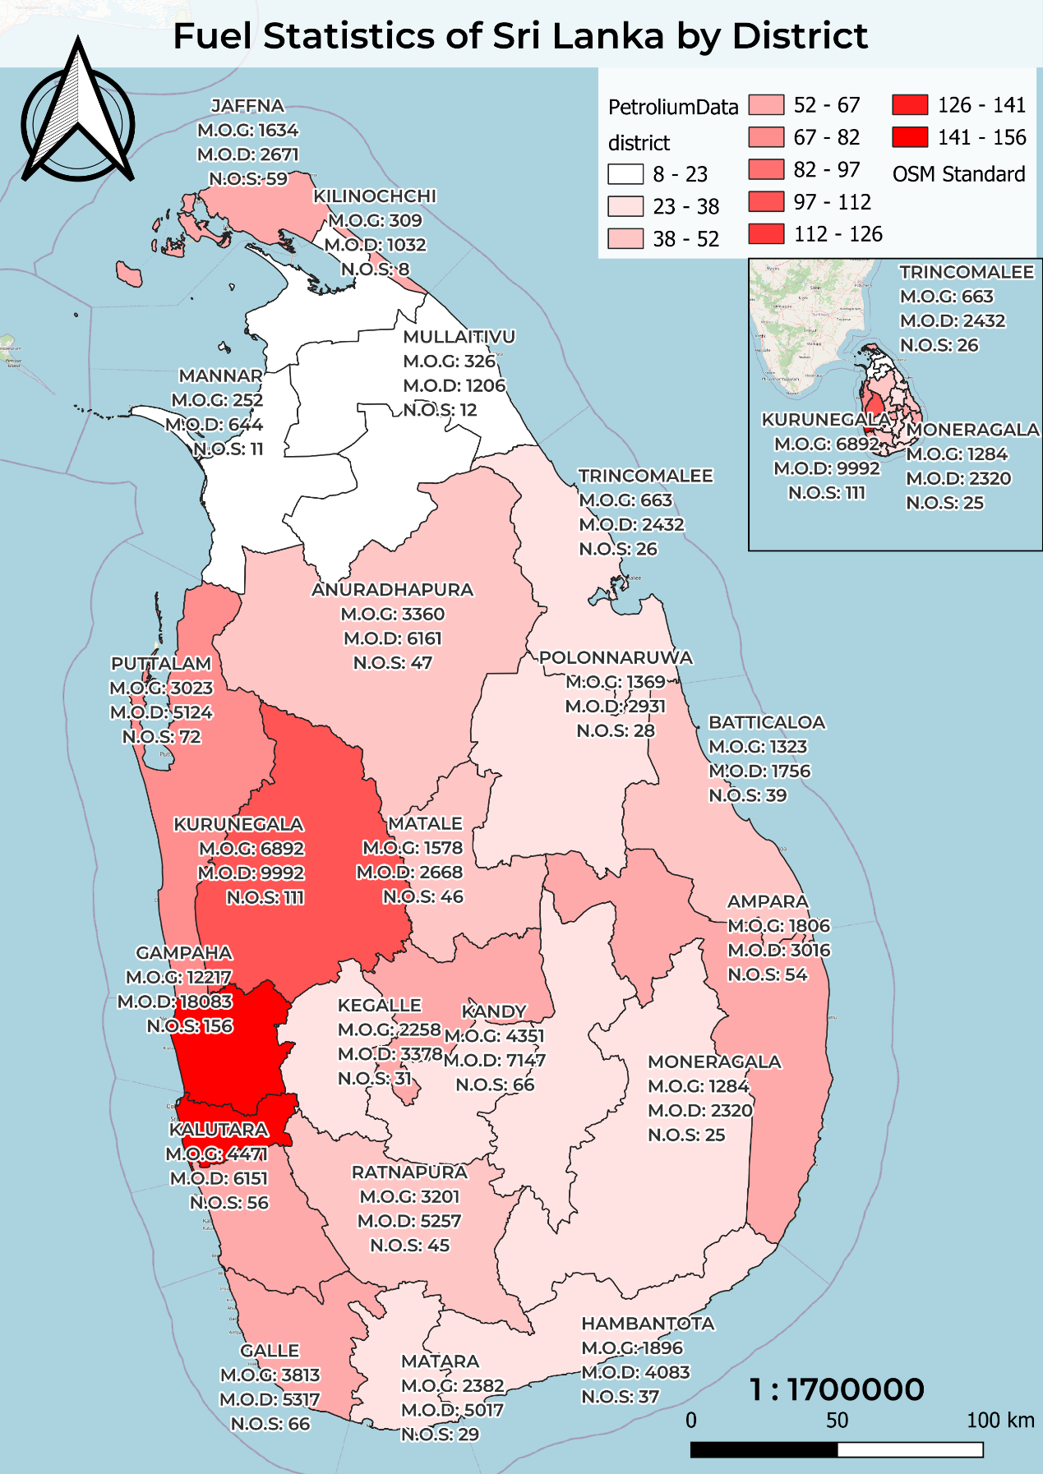

Figure .: Fuel statistics of Sri Lanka by District

### Fuel statistics of Sri Lanka by district

The map provided in figure 6.2 shows the thematic map of Sri Lanka by the no. of sheds in each district. According to the graph, the highest number of sheds are available in the Gampaha and Colombo districts. The lowest number of sheds are available in the Kilinochchi, Vavuniya, Mullaitivu and Mannar Districts. Also the means of gasoline distribution and diesel distribution are also provided in the labels of the map. The darker color shows the highest number of sheds, and the lighter colors show the least number of sheds.

Therefore it is safe to assume that the places with dense population have more no. of sheds and more distribution of diesel and gasoline.

### Geo Spatial Database

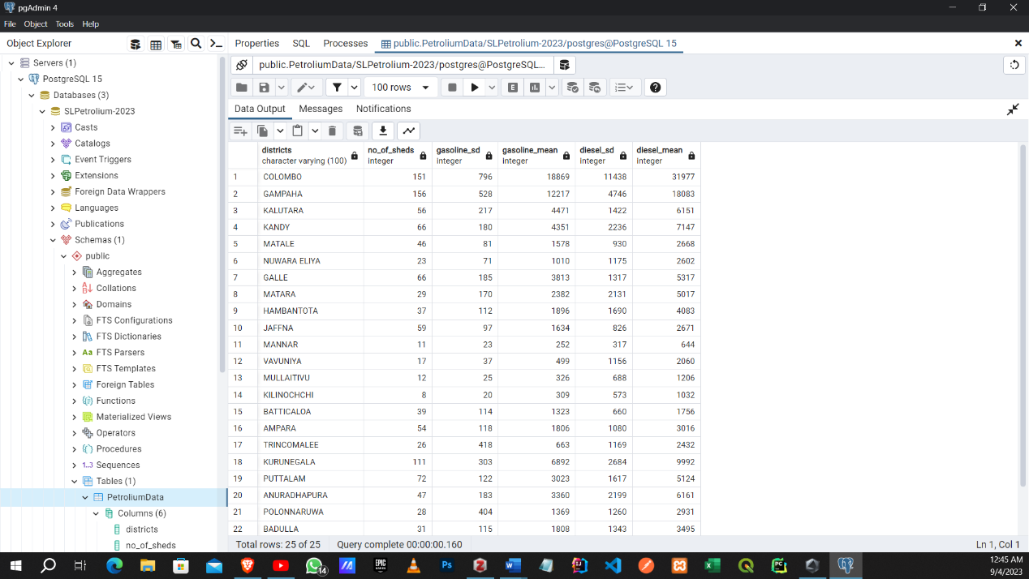

Figure .: Geo Spatial database created for SL Petroleum distribution.

The figure 6.3 depicts the geo spatial database created for the SL Petroleum distribution data provided by the Sri Lanka Sustainable Energy Authority.

**ALL STEPS RELATED TO THIS CHAPTER ARE IN** **APPENDIX F**

# 

## LOCATIONS FOR RENEWABL ENERGY GENERATION

The following chapter is about feasible locations for Renewable Energy Generation in Sri Lanka identified by the Sri Lanka Energy Authority. A map is drawn to pinpoint the exact feasible locations using Google Earth Pro and QGIS.

Most common renewable energy generation methods in Sri Lanka are Wind Power, Solar Power, and Biomass power. Therefore the most suitable and feasible locations for the development of these sites must be identified. Sri Lanka Sustainable Energy Authority have provided some such locations for the development of renewable energy.



### Factors considered when selecting a location.

Sri Lanka Sustainable Energy Authority have considered multiple factors when selecting a location for the development. For instance for selecting solar power development locations they tend to check the place with sunlight coverage throughout the year, easy to maintain places and places with least harm to the environment. When considering factors for wind power they have considered places with the most windfall. In addition to that the Monaragala, Polonnaruwa, and Batticaloa district is selected for the development of Biomass power plants.

### Feasible Locations

#### Solar Power

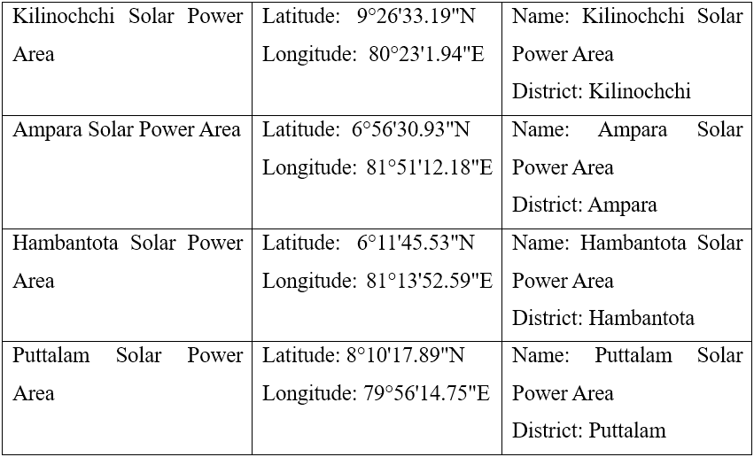

Table .: Feasible locations for Solar Power

#### Wind Power

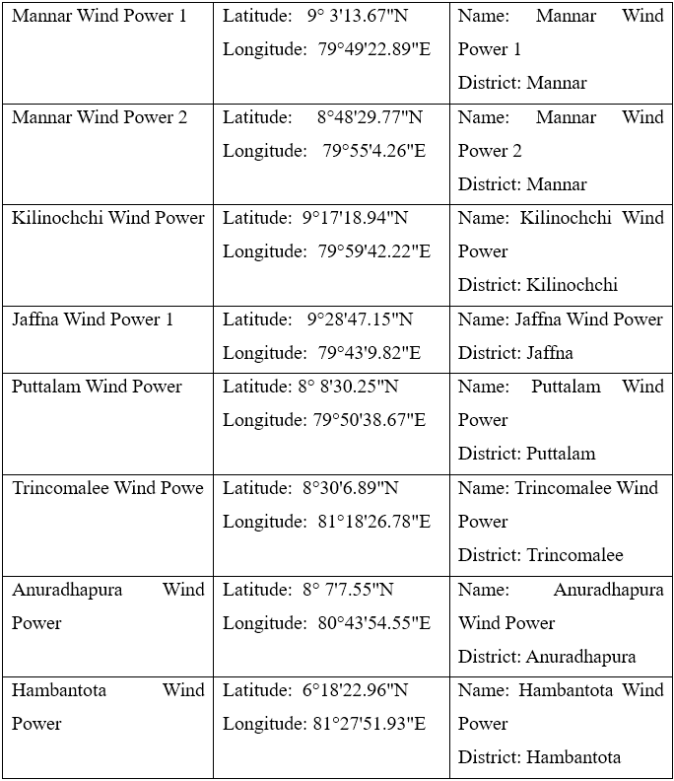

Table .: Feasible locations for wind power development

#### Biomass

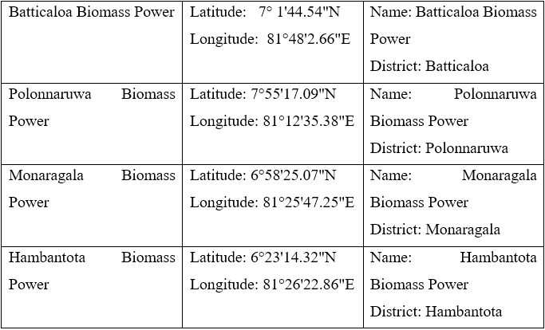

Table .: Feasible locations for biomass power development

### Mapping the locations

By considering all these locations as potential locations for renewable energy development they are mapped in Google Earth Pro and a graph representing the locations are drawn and depicted in figure 7.1 below.

According to the figure in 7.1, there are multiple locations suitable for renewable energy generation and they are marked with certain symbols. The triangle symbol represents potential land for solar power development. Pink circle represents feasible land for wind power development and black circle represents biomass power development.

Almost all of the wind power locations are situated in coastal areas and solar power locations are situated in uninhabited places.

**ALL STEPS RELATED TO THIS CHAPTER ARE IN** **APPENDIX G**

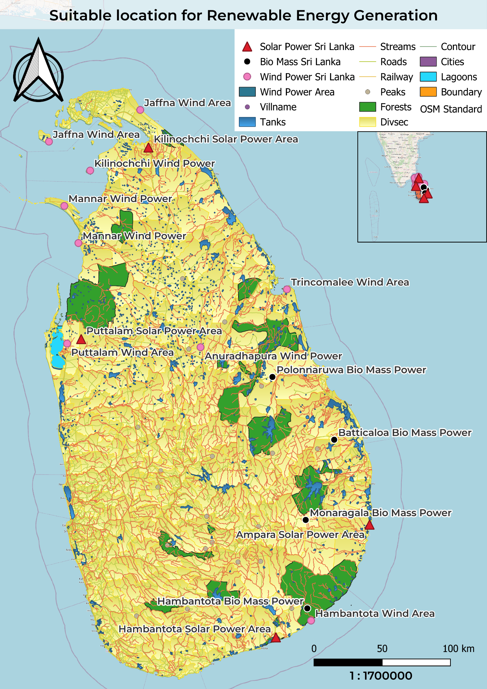

Figure .: Feasible locations for renewable energy development

# 

## RENEWABLE ENERGY RESEARCH CENTER FOR KANDY

The following chapter consists of the map that is developed to find the suitable land for the newly developing ‘*Regional Research Center for Renewable Energy*’ in Kandy. The suitable area in the map is developed using the criteria provided in the task and the total number of buildings within the suitable area at present, land area occupied by the buildings, and total suitable land area is found out.

1. 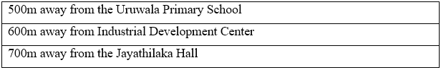

### Criteria for the suitable Area

Table .: criteria for the suitable area

The above table 8.1 mentions the requirements of the land area where the new research center is to be developed.

### Suitable area for the newly developing research center

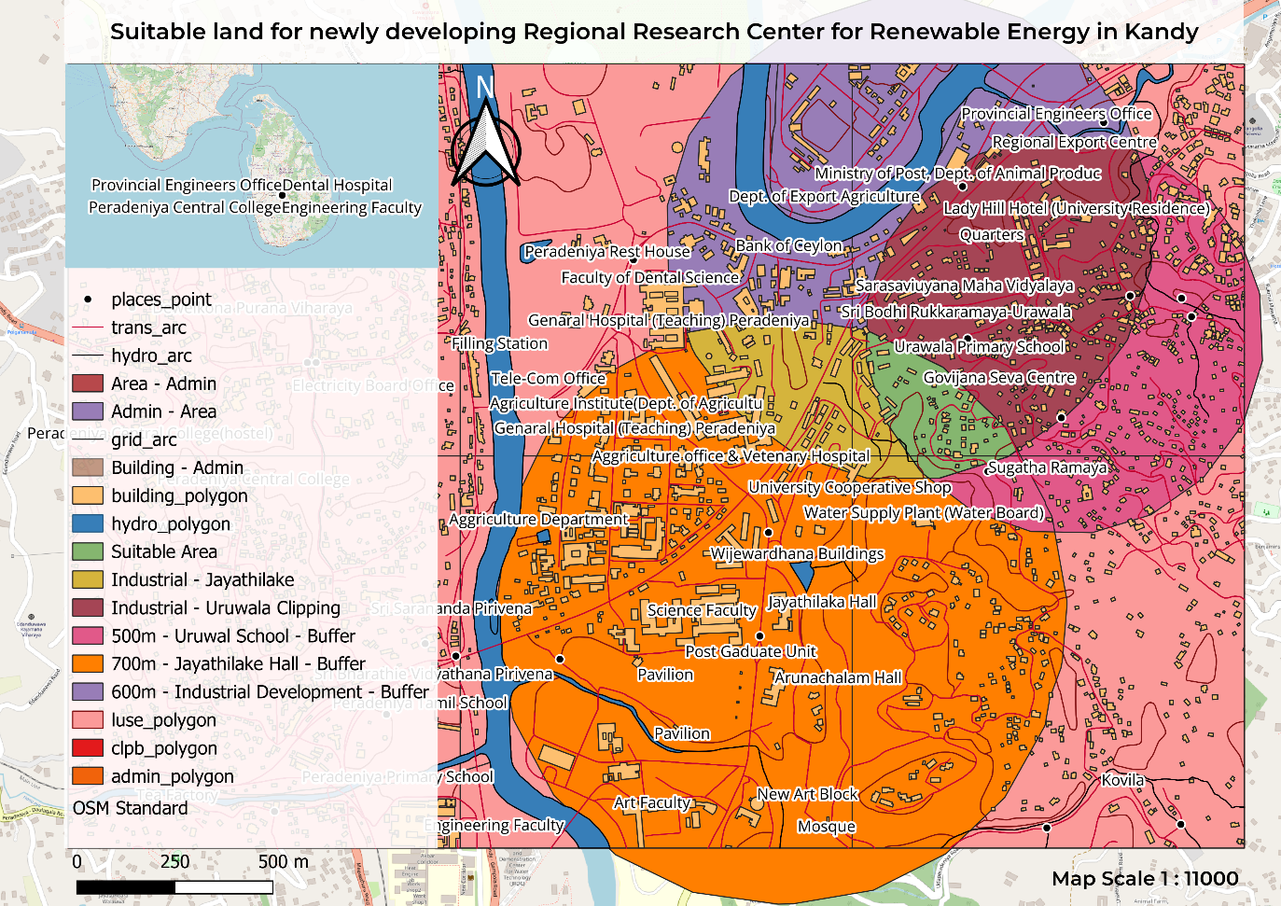

Figure .: Suitable area for the research center

Figure 8.1 shows the suitable area that is selected for the development of regional research center in green color. This piece of land is selected by meeting all conditions put forth by the department. The orange circle visible in the map is the buffer drawn to show the 700m radius of Jayathilaka hall, 600m radius circle drawn around the Industrial development center is purple and Uruwala primary school’s circle is pink with a radius of 500m. The places are then intersected to find the most suitable piece of land for the newly developed research center.

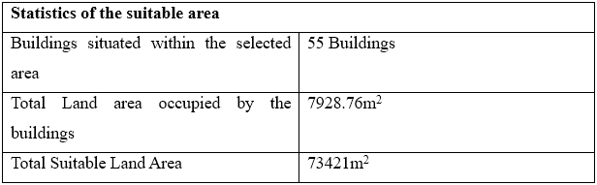

Table .: Statistics of the suitable location

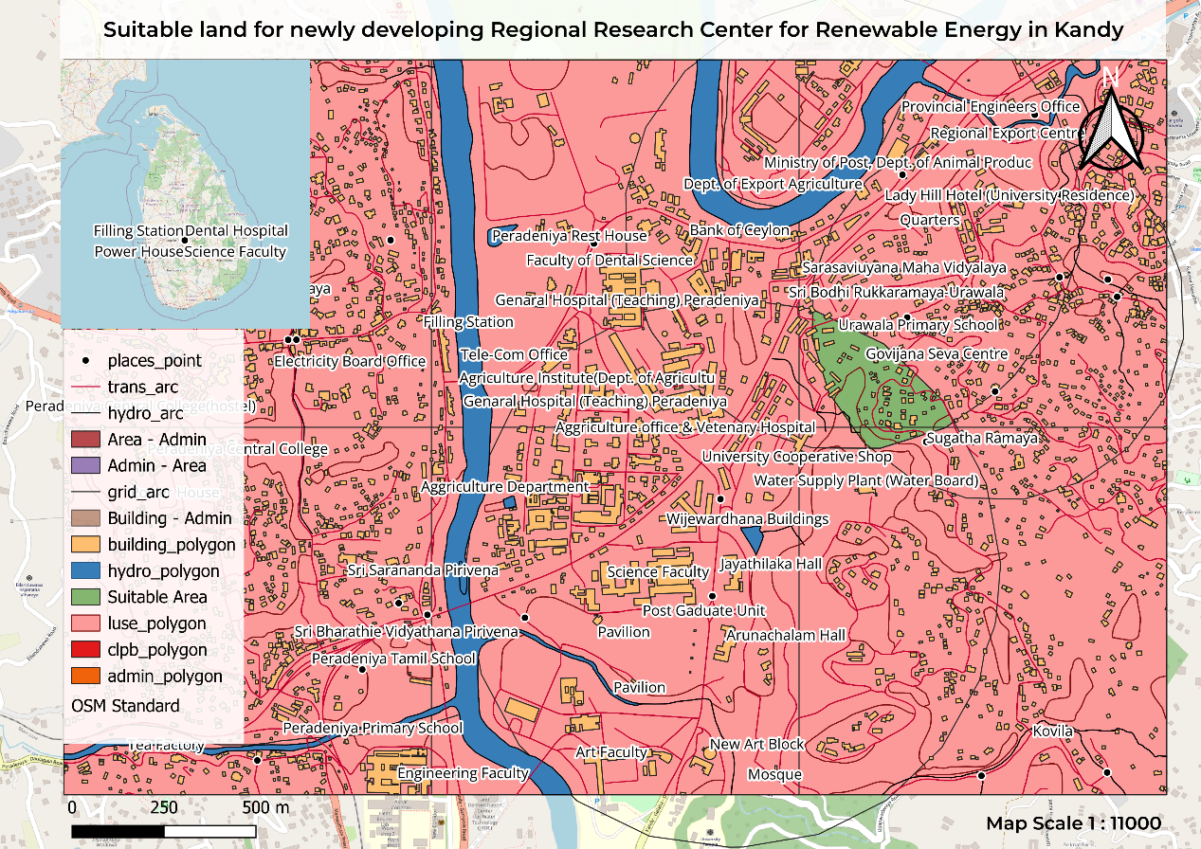

Figure .: Suitable area

**ALL STEPS RELATED TO THIS CHAPTER ARE IN** **APPENDIX H**

# CONCLUSION

The above report comprises the use of geo-spatial analysis and statistical analysis. This report has approached combining geospatial and statistical analysis to explore critical aspects of energy efficiency and renewable energy development.

The first chapter consists of associations between building cooling with various factors affecting residential and commercial electricity consumption. This chapter laid the foundation for a deeper understanding of energy-saving strategies.

By using the data collected from Chapter One a statistical model to predict cooling load through regression analysis is provided. This model provides a powerful tool for optimizing energy consumption within buildings, contributing to the broader goal of energy conservation.

In Chapter Three, we uncovered lands ripe for wind power plant development across Sri Lanka's districts, leveraging data from the Renewable Energy Resource Development Plan. In Chapter Four, we examined the potential for solar power development and analyzed how solar energy can be a potent force in mitigating energy sector challenges.

Chapter five provided a small area of Hambantota, which is digitized by highlighting features such as solar parks, forests, water bodies and others by creating shape files. In Chapter Six, geo spatial analysis is done by creating a database in Postgres SQL and presenting the fuel distribution data in a thematic map.

Chapter Seven consists of the feasible locations for renewable energy development. Locations are pinned using Google Earth pro and the mapping is done using QGIS. The final chapter analysis is done to select the most suitable location for the newly developing regional research center in Kandy. And finally, the report ended with the conclusion.

# GANTT CHART

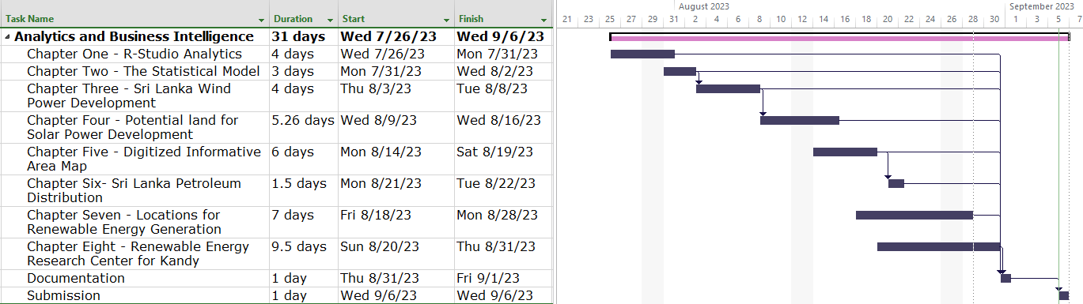

# REFERENCES

Sustainable Energy Authority, 2023. *New Renewable Energy*. [online] Available at: <https://www.energy.gov.lk/index.php/en/renewable-energy/new-renewable-energy> [Accessed 28 August 2023].

# APPENDIX A

**Chapter One R Studio Codes**

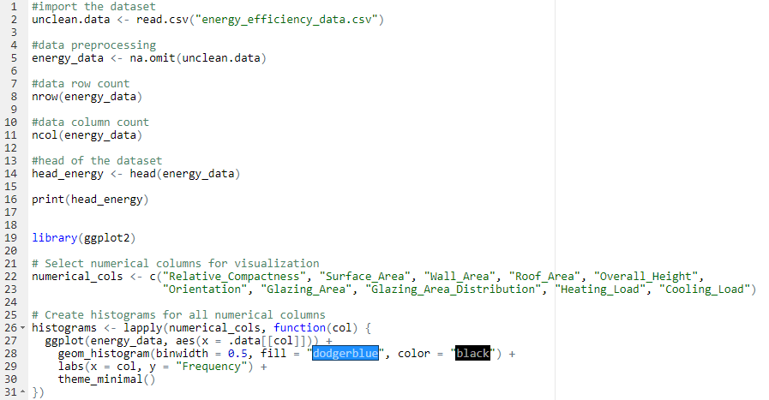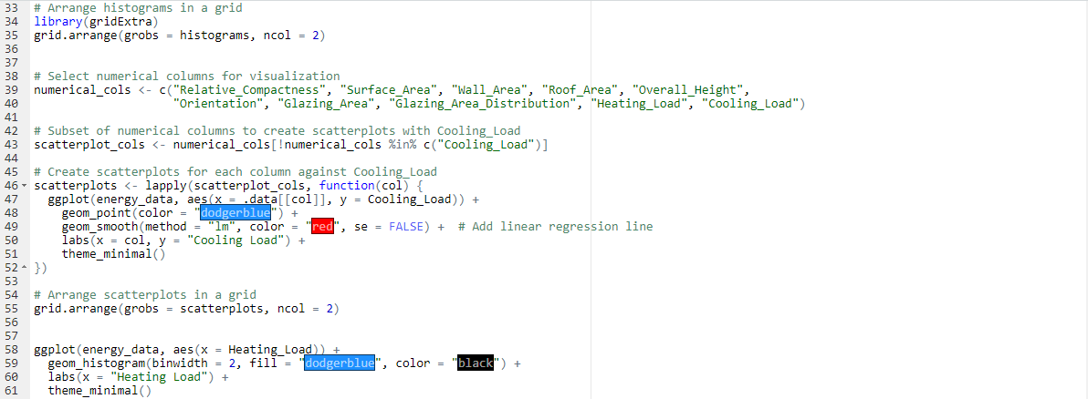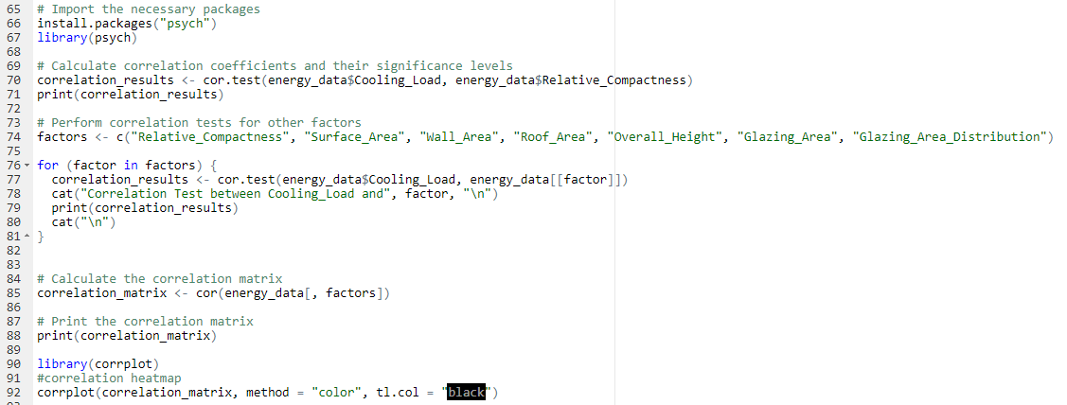

# APPENDIX B

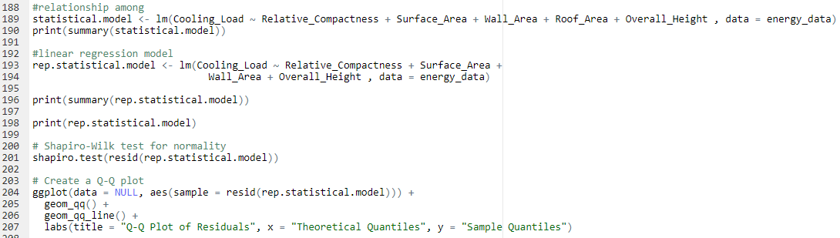**Chapter Two R Studio Codes**

# APPENDIX C

Adding OSM Standard Map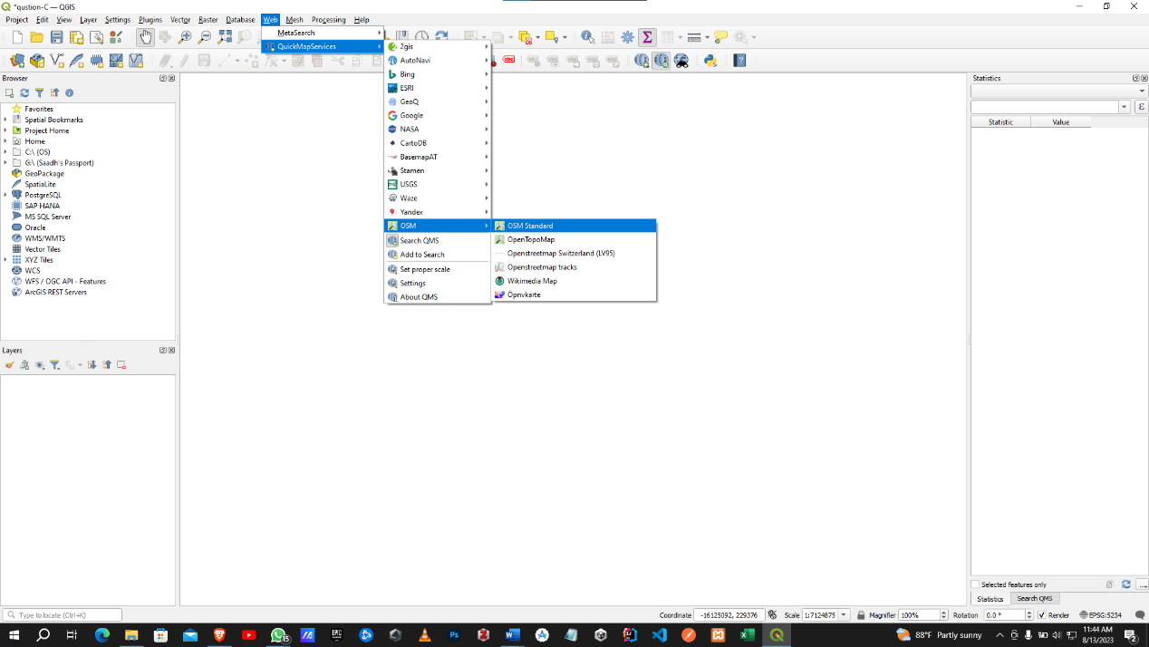

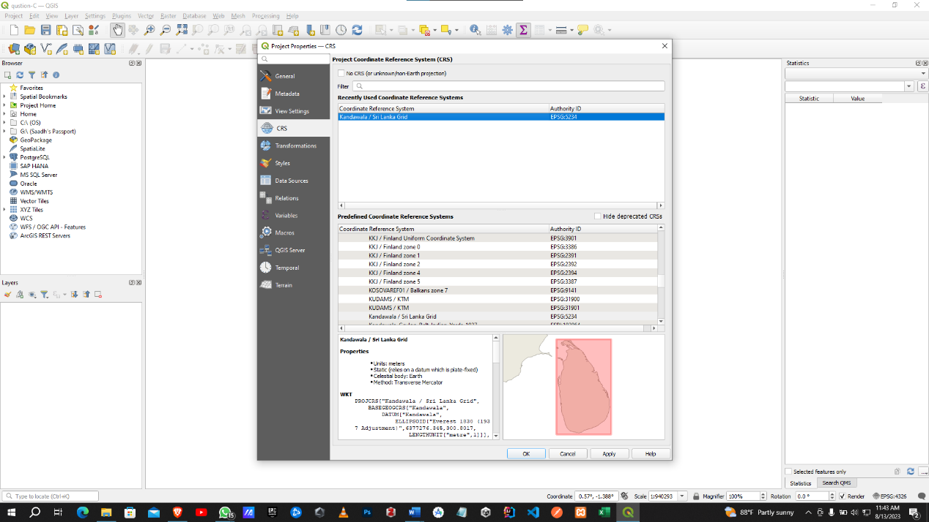Selecting Grid system

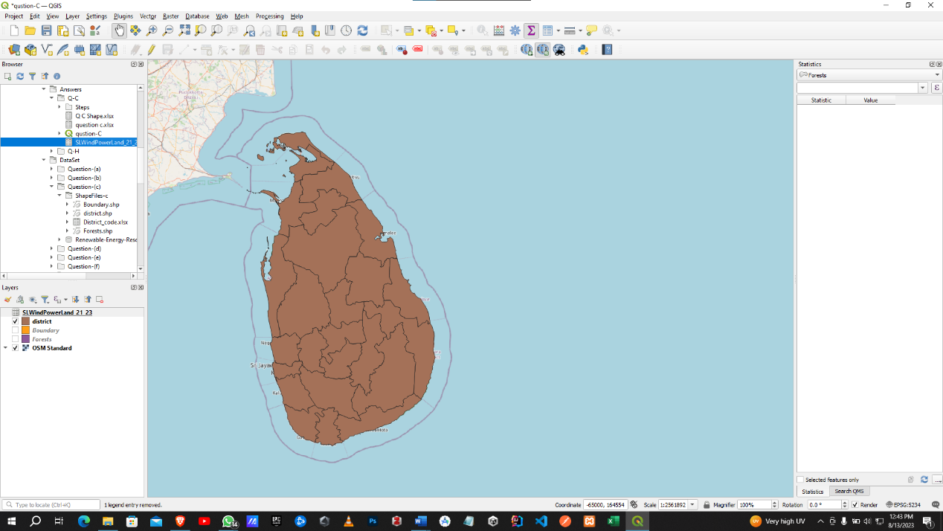Adding Shape files

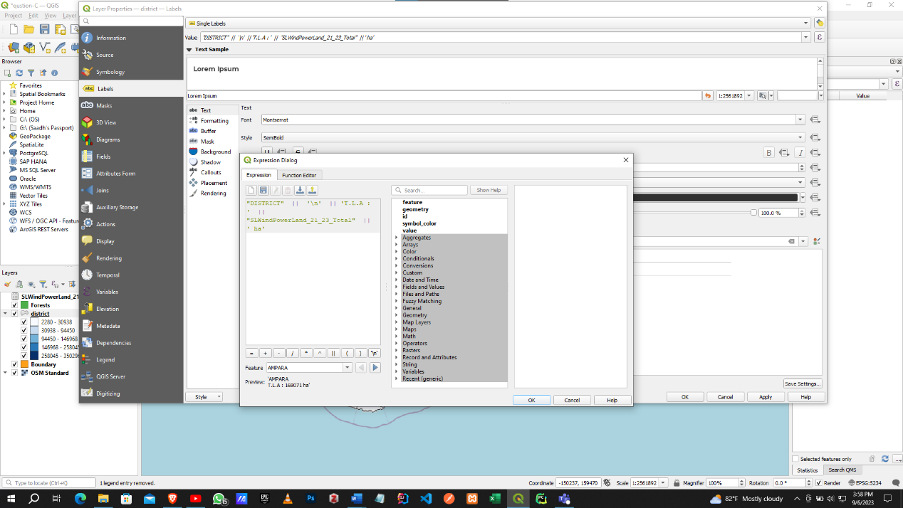Adding labels.

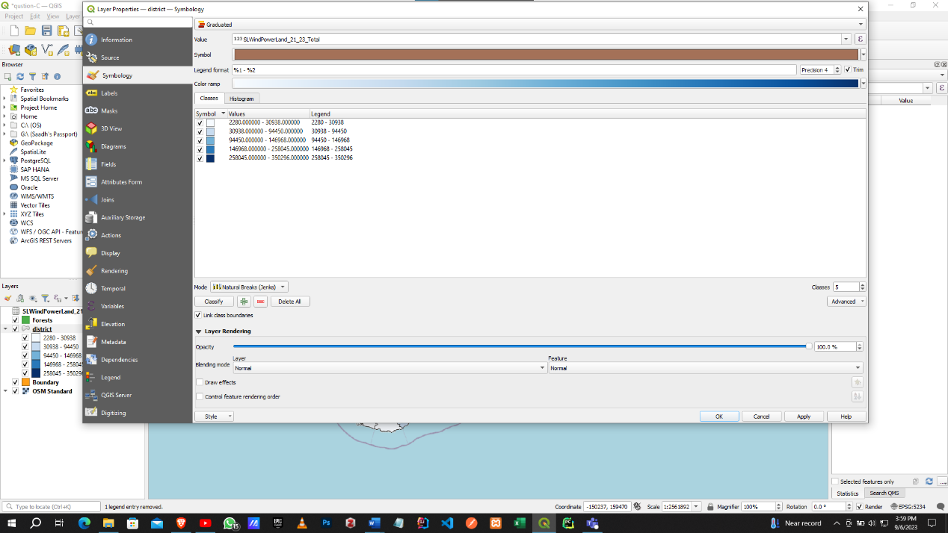Adding Symbology

# APPENDIX D

Added the shape files and SLSolarPower21_23.csv dataset.

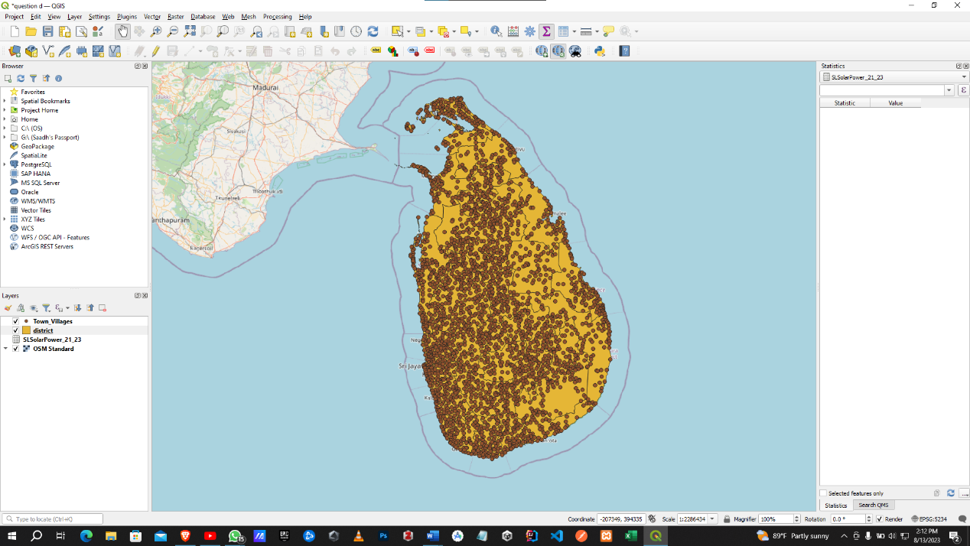

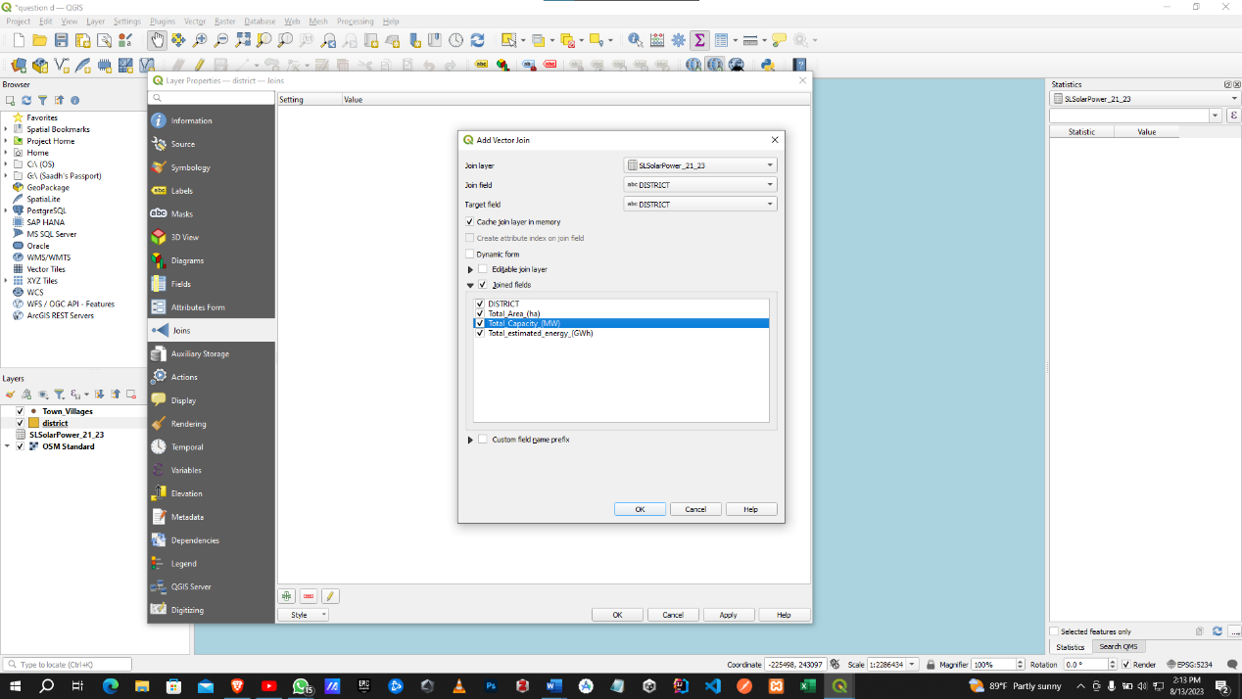Joining the shape file and dataset

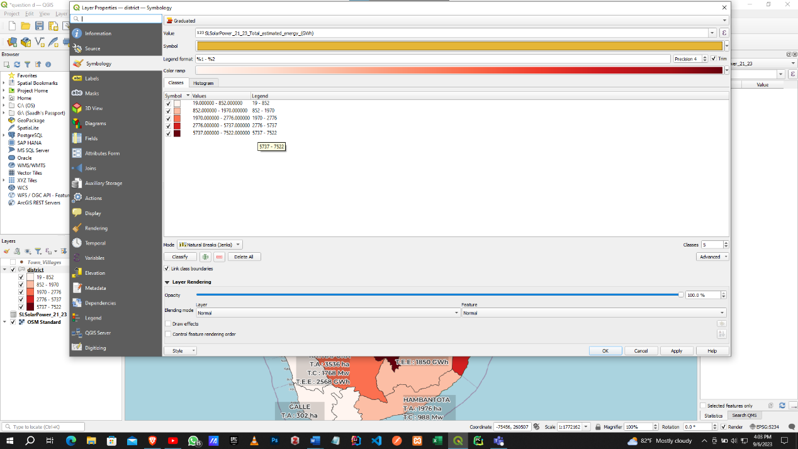Adding Symbology

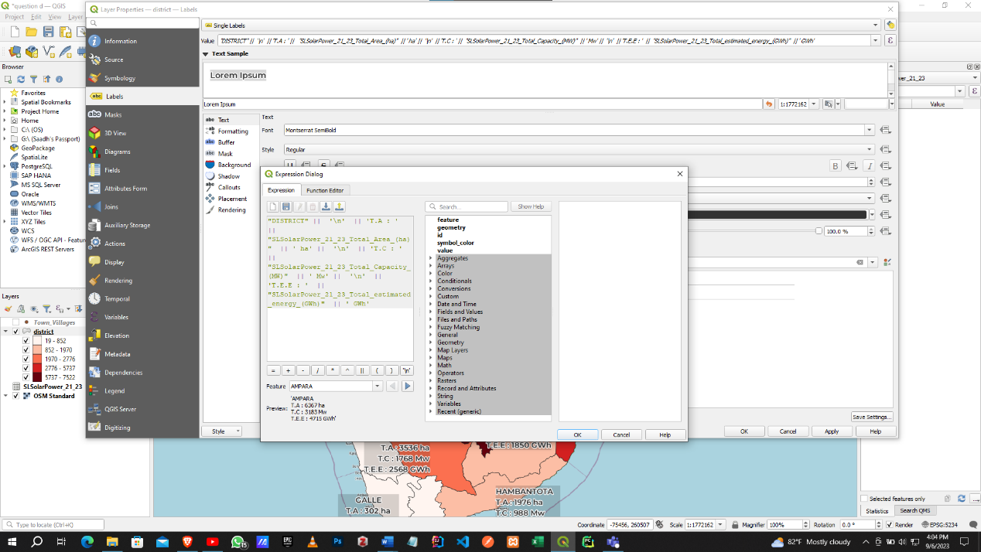Adding labels

# APPENDIX E

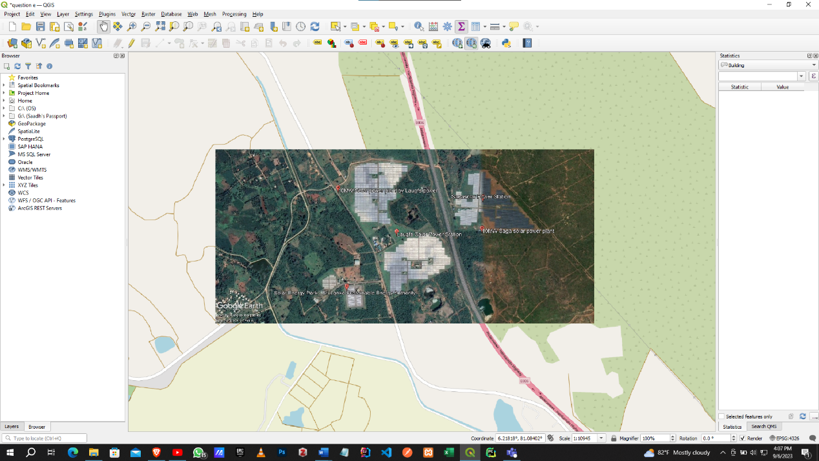Added the image on the OSM standard map.

Creating shape files

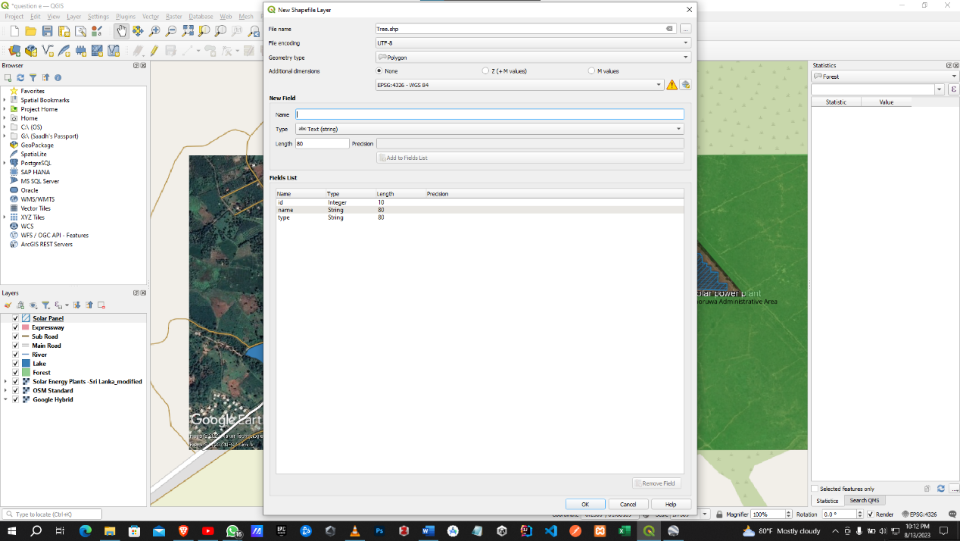

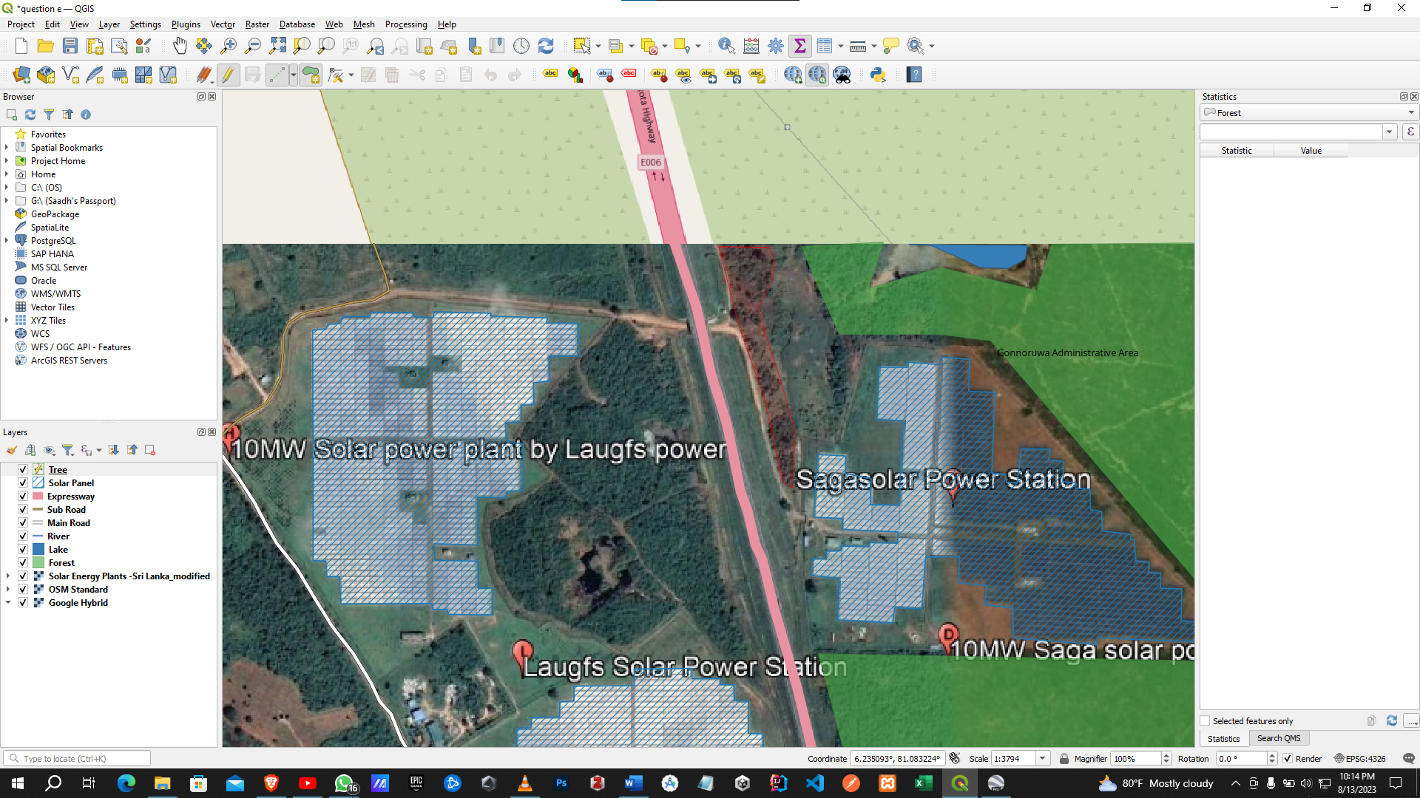Selecting Areas for the shape file

Saving Attributes

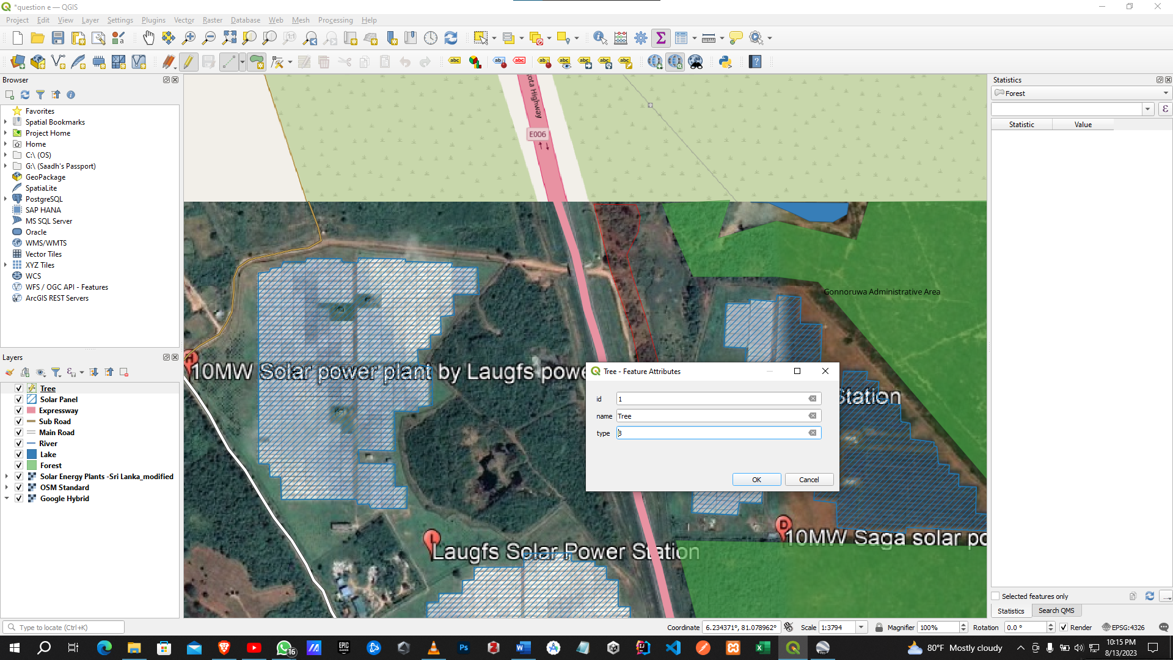

Created shape files.

# APPENDIX F

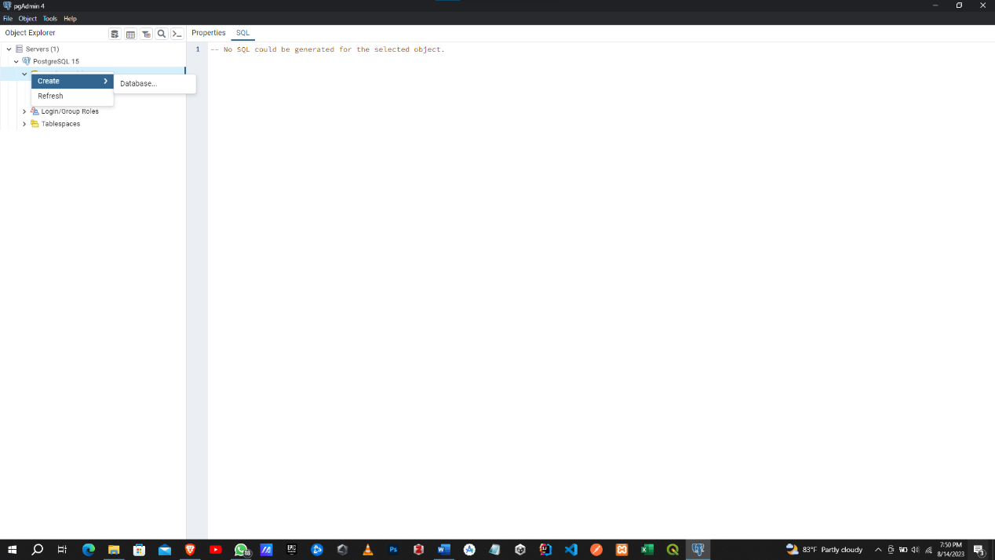Create Postgres SQL database.

Give the name to the database.

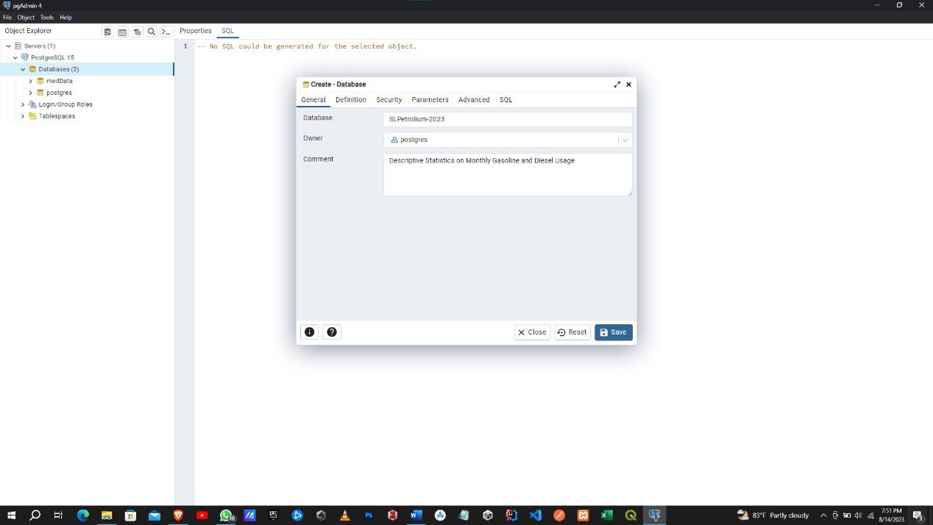

Create table.

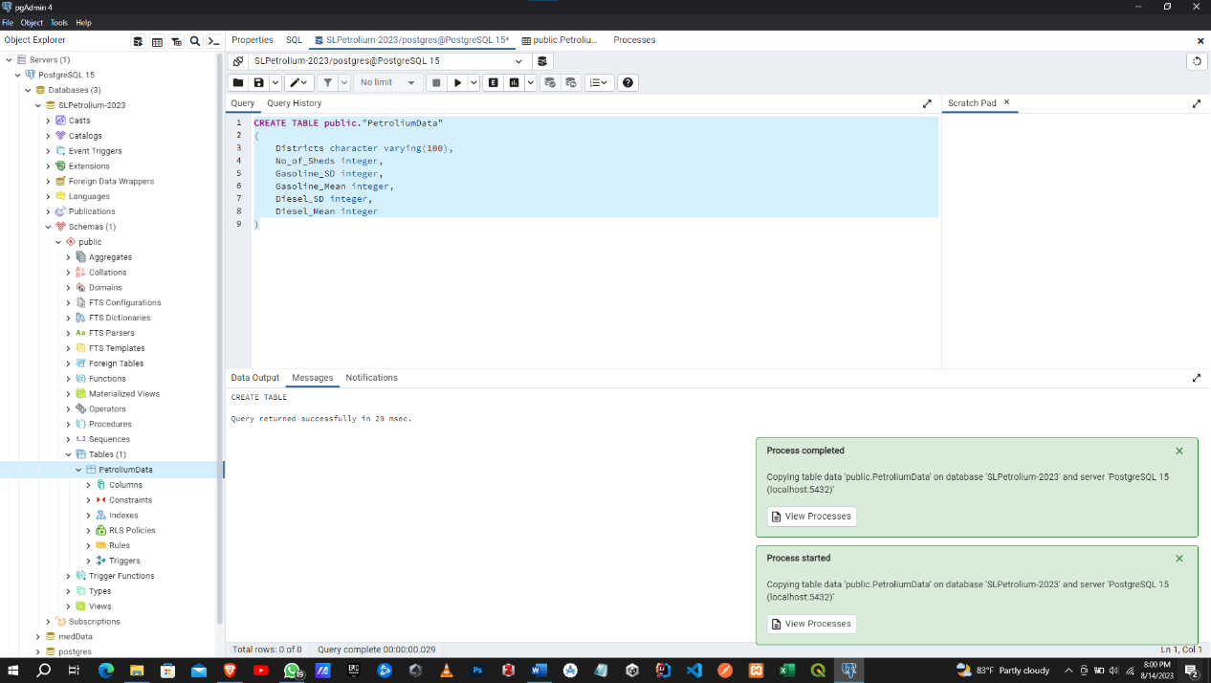

Import the dataset.

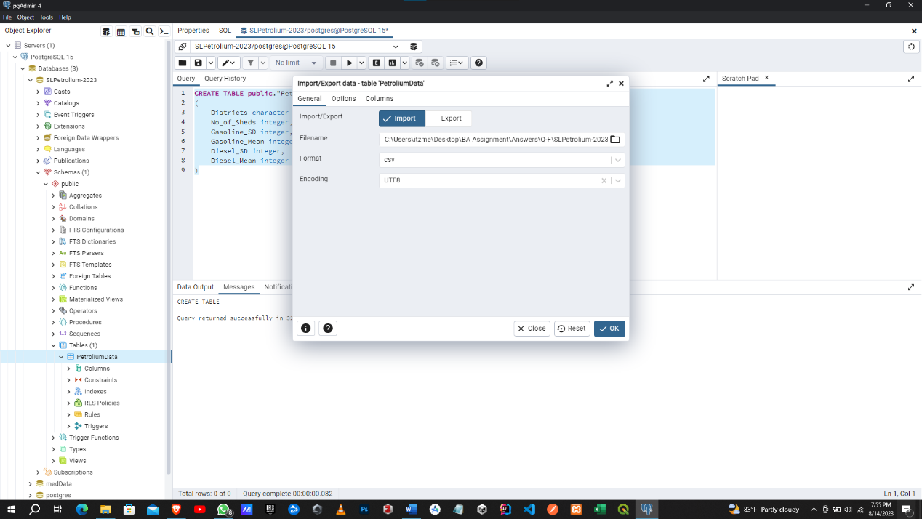

Link the database with QGIS.

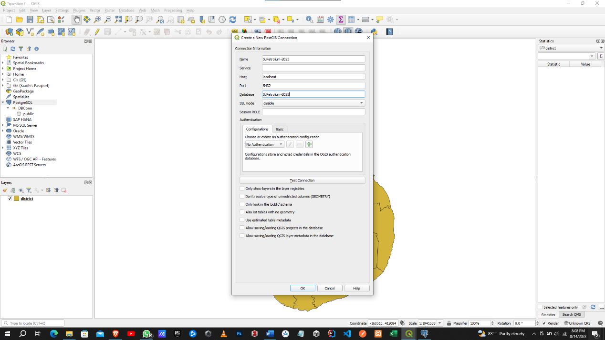

Test the DB Connection

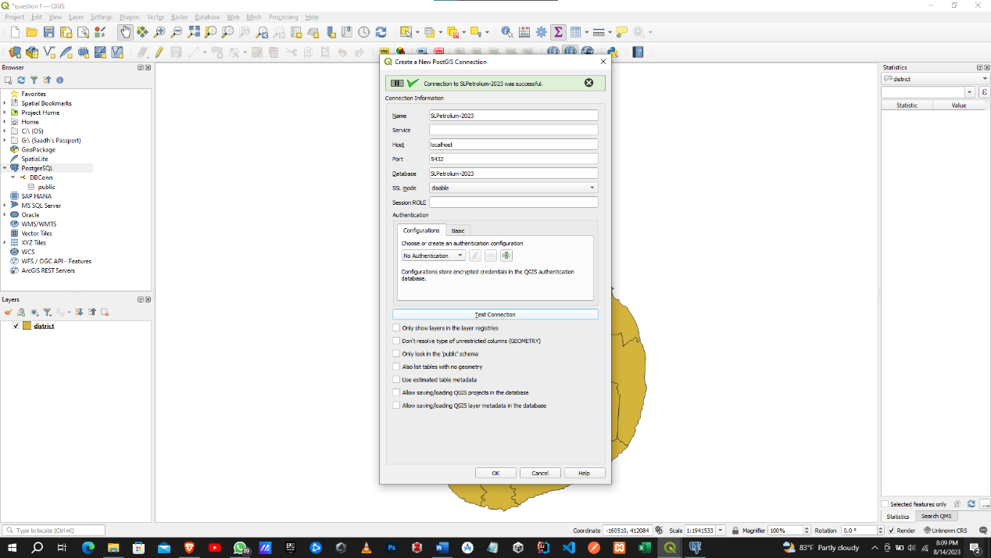

Check whether the data is retrieved.

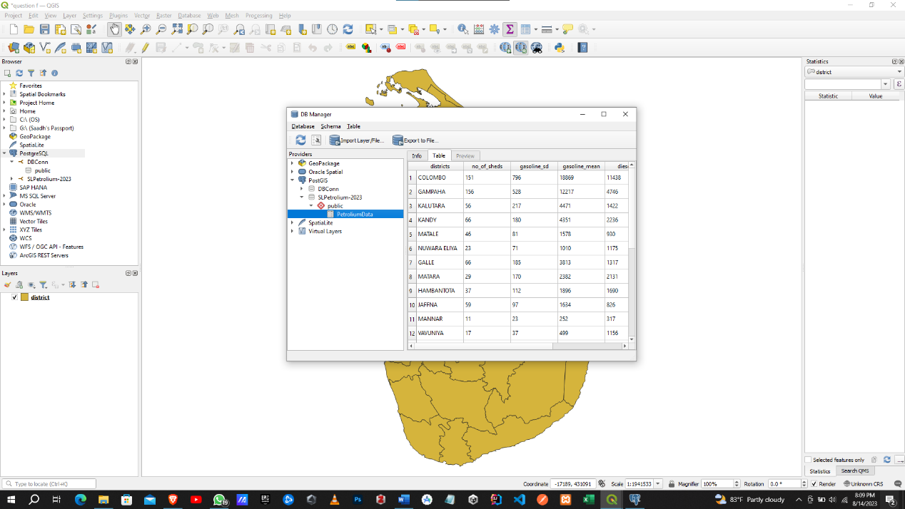

Join it with the shape layer.

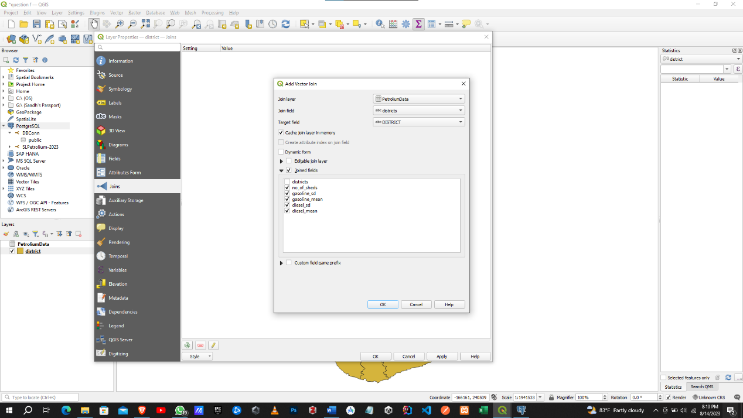

Adding Symbology

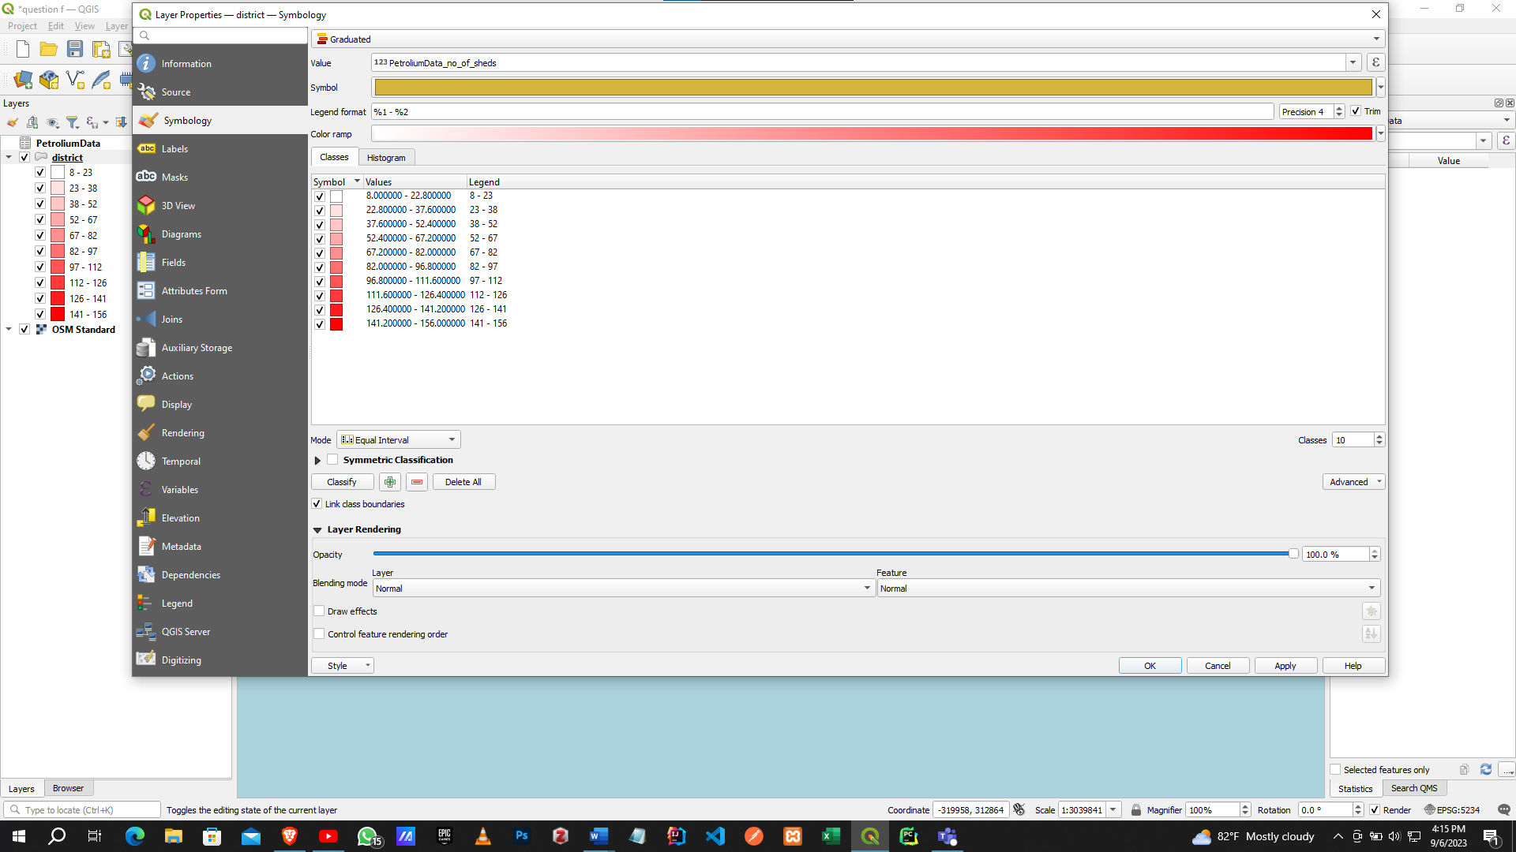

Adding Labels

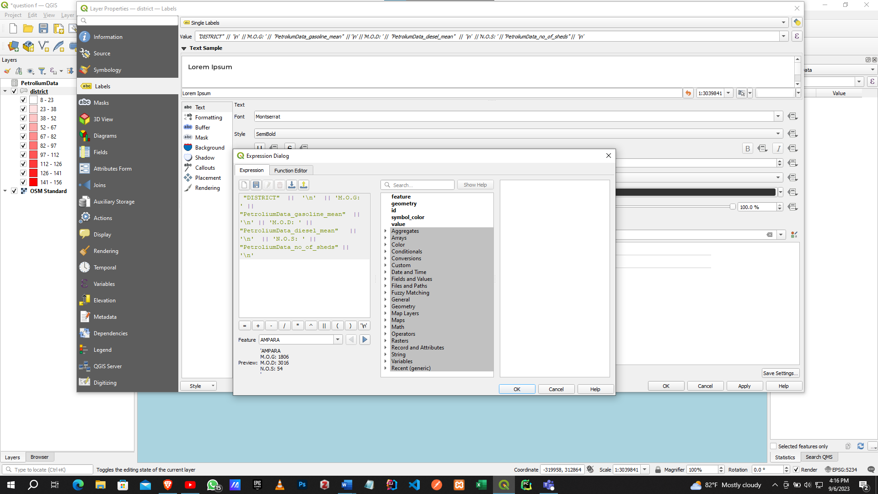

# APPENDIX G

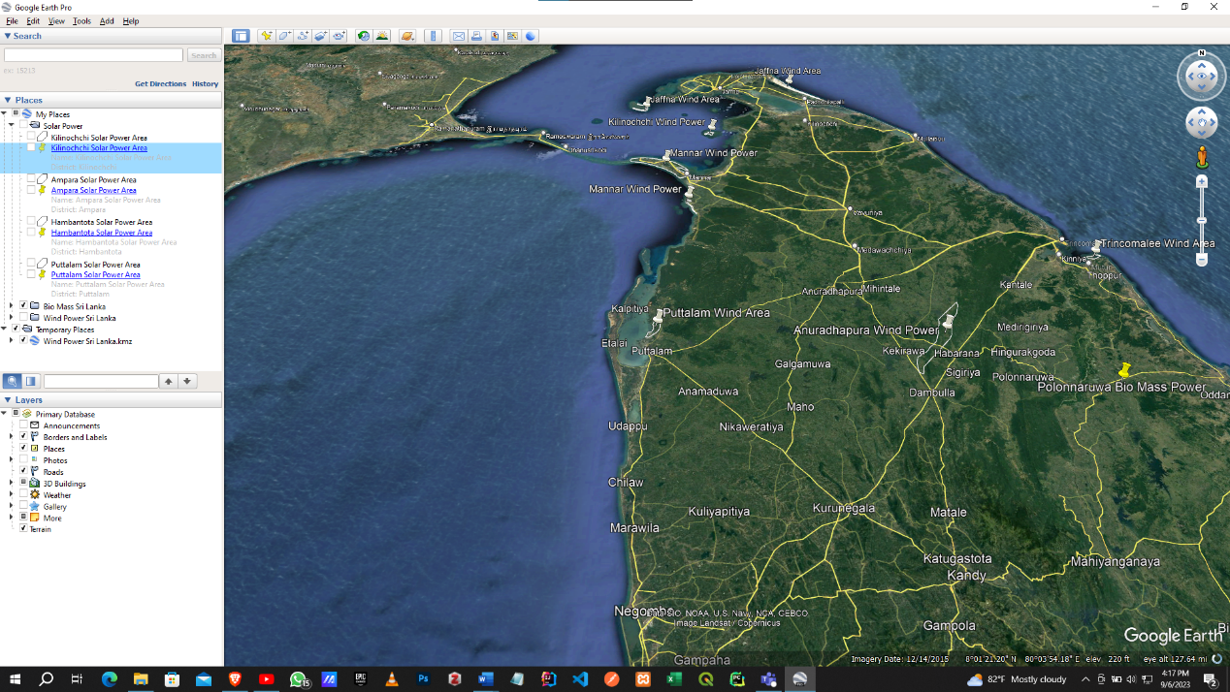Add points and polygons using Google Earth Pro

Add place details.

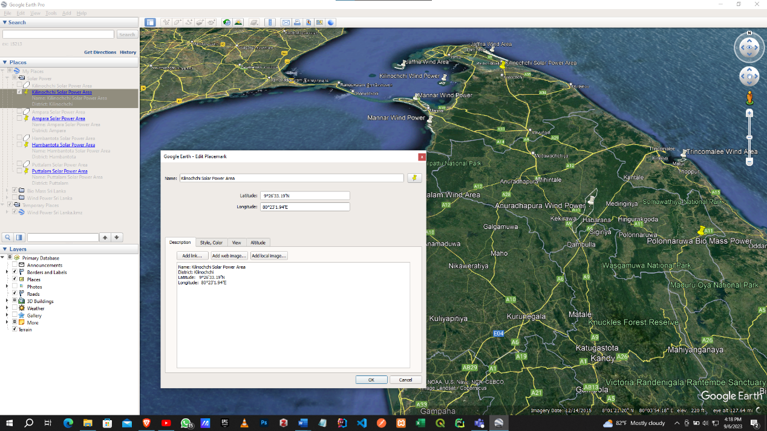

Save them as KML files

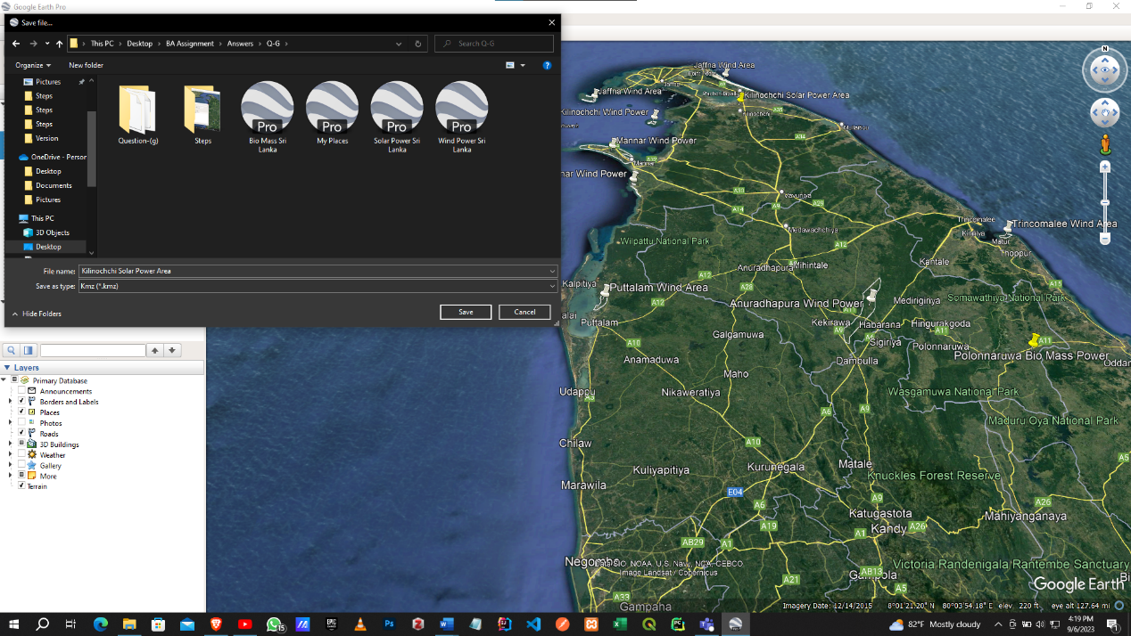

Open QGIS and added the shape files

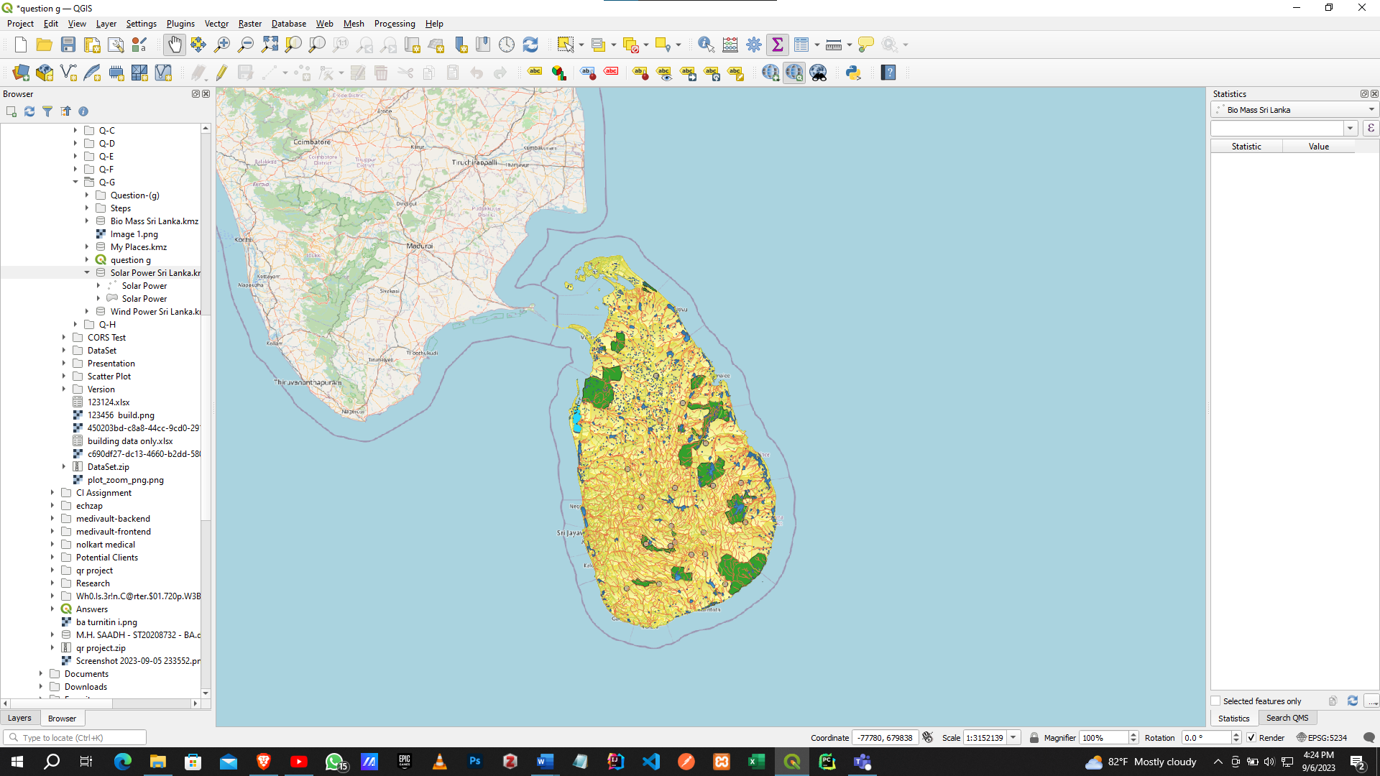

Add the KML Files

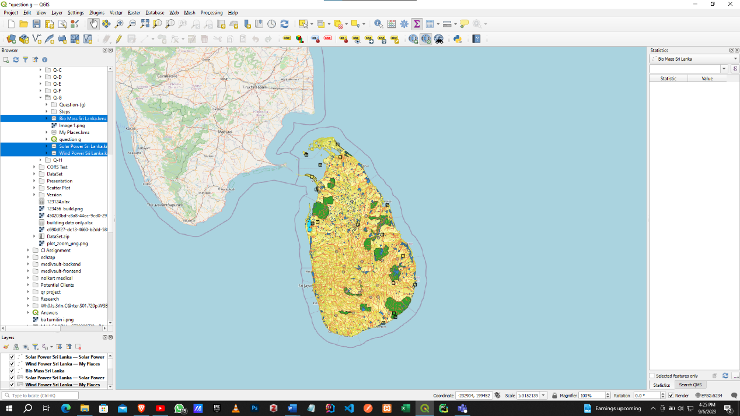

Add Symbology.

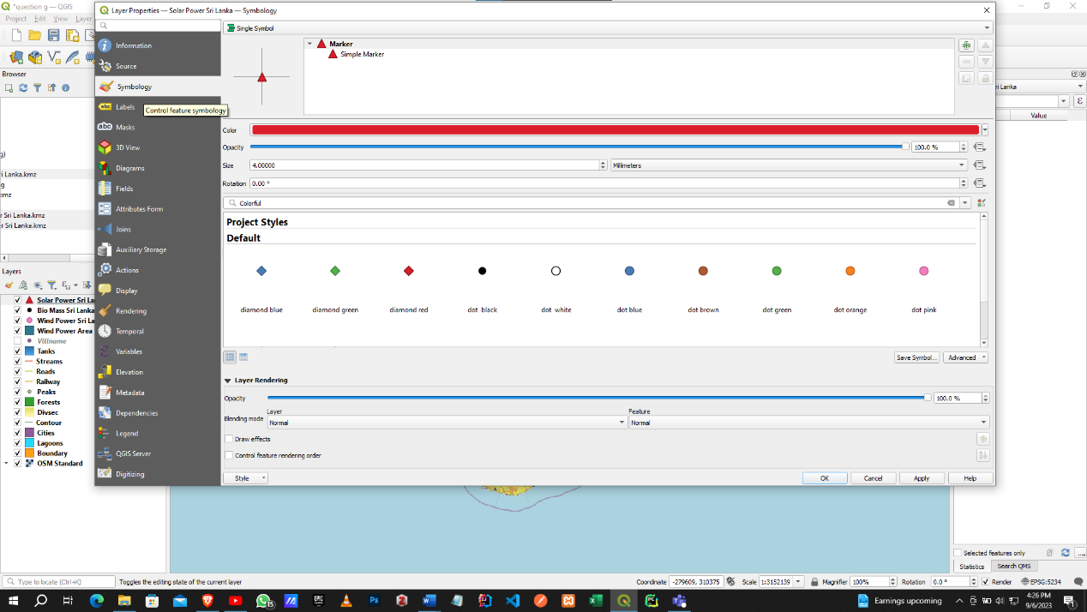

Add labels.

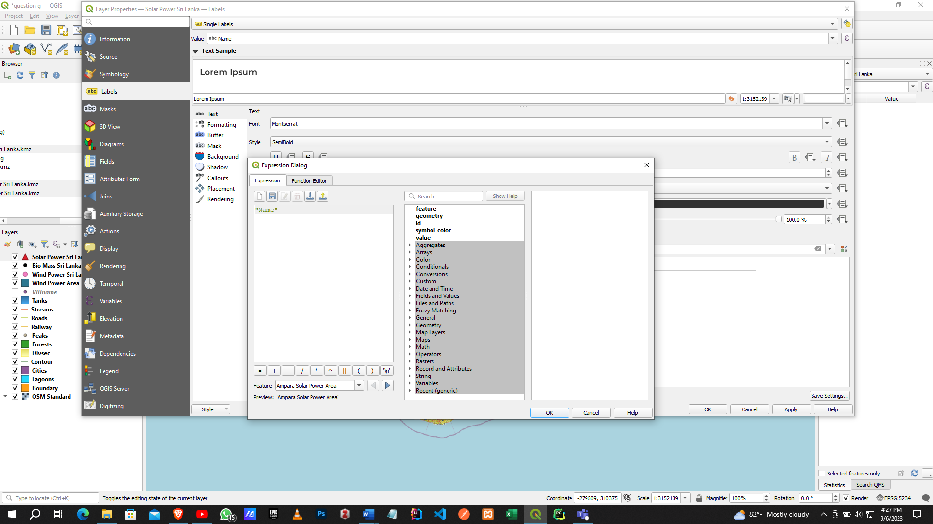

Final

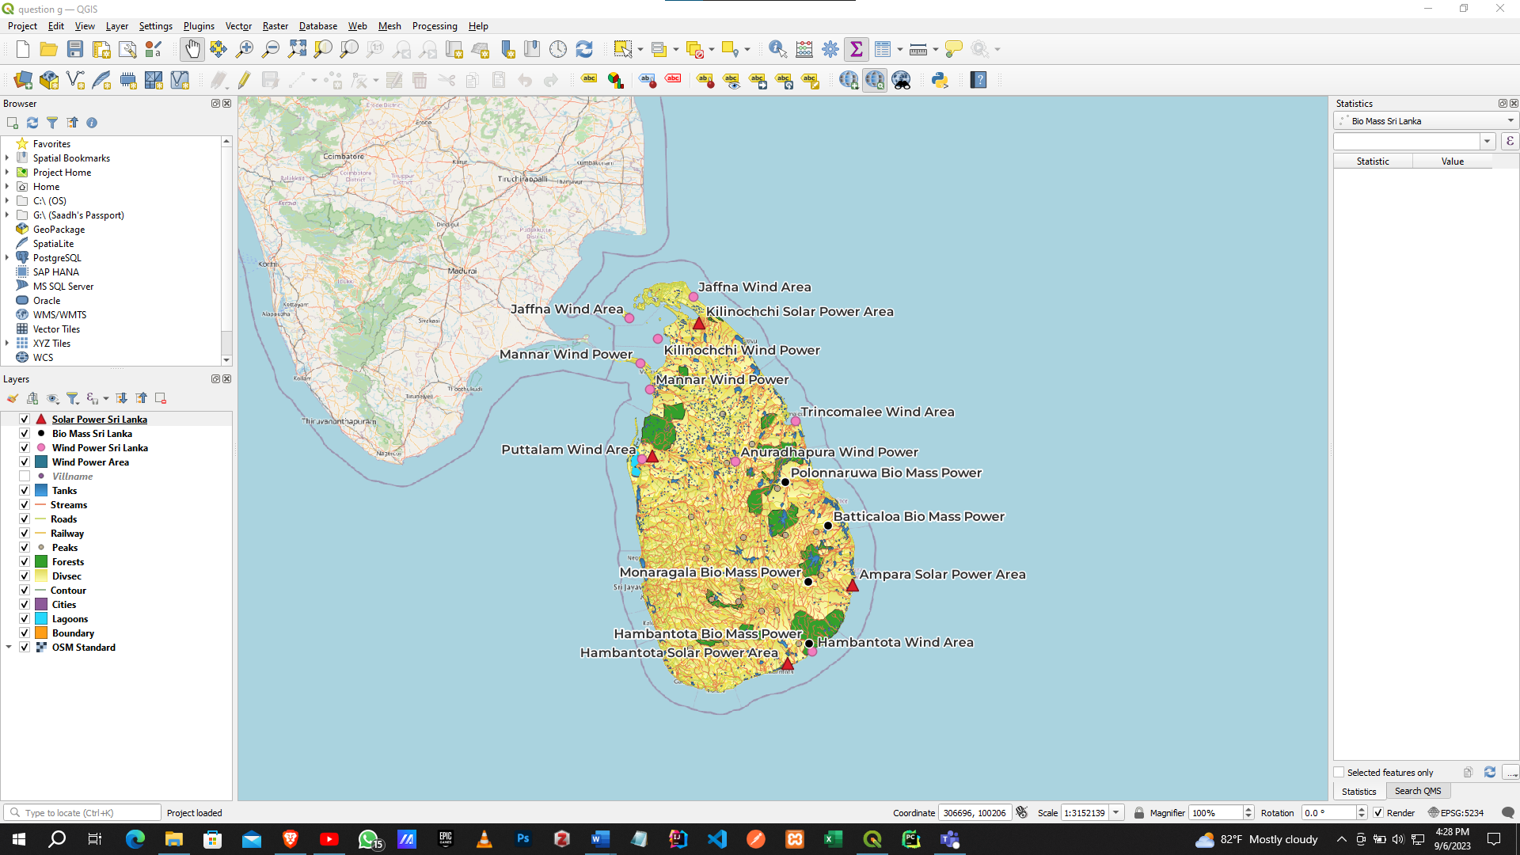

# APPENDIX H

All steps related to question H are in order

